Theme/Term | Autumn 1 |  |  | Autumn 2
Planning Sequence | 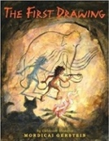  The First Drawing  Mordicai Gerstein | 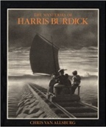  The Mysteries of Harris Burdick  Chris Van Allsberg |  | 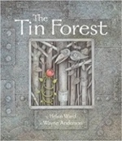  The Tin Forest  Helen Ward | 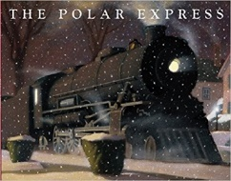 The Polar Express  Chris Van Allsberg
Outcomes | Own historical narratives  Character descriptions, diaries, recounts | Extended fantasy narrative  Setting description, short first person narrative, dialogue, speech, action scene |  | Persuasive information leaflets  Persuasive posters, information leaflets, postcards, diaries, wishes, setting descriptions | Hope and Belief  Rhyming couplets, first person narrative,
Theme/Term | Spring 1 |  |  | Spring 2
Planning Sequence | 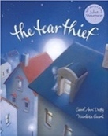  The Tear Thief  Carol Ann Duffy |  | 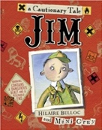  Jim, A Cautionary Tale  Hilaire Belloc | 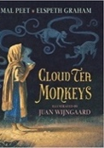  Cloud Tea Monkeys  Mal Peet & Elspeth Graham | 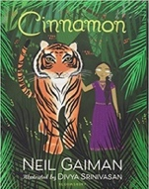  Cinnamon  Neil Gaiman
Outcomes | Persuasive information leaflets  Persuasive posters, information leaflets, postcards, diaries, wishes, setting descriptions |  | Narrative poems  Warning posters, alternative endings, performance poetry, letter of apology | Non-chronological reports Descriptions, ‘how to’ guides (instructions), letters, discussions | Own version mythical tales  Diaries, informal letters, dialogue, adverts, limericks and other poetic forms
Theme/Term | Summer 1 |  |  | Summer 2
Planning Sequence | Cinderella of the Nile  by Beverley Naidoo  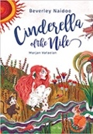 |  | 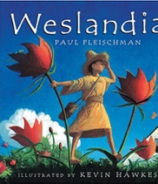  Weslandia  Paul Fleischman | 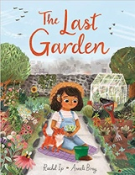  The Last Garden  Rachel Ip | 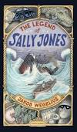 The Legend of Sally Jones  Jakob Wegelius
Outcomes | Own version narratives  Descriptive passages, how to guides, letters, discussions, non-chronological reports |  | Imagined land narratives  Character description, informative posters, persuasive leaflets, log book | Own version extended narrative  Setting descriptions, advertisement/ poster, retelling, instructional flyer, social media updates, dialogue | Confidence and Caution  Birth certificate, letter, class ‘book of tricks’, newspaper article, dialogue, advert, diary entry, leaflet, telegram, booklet, ‘so long’ note

