Theme/Term | Autumn 1 |  | Evolution & inheritance Autumn 2
Planning Sequence/  Spelling Seed Text | 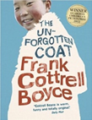  The Unfogotten Coat  Frank Cottrell Boyce | The Hidden Forest  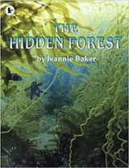  Jeannie Baker | 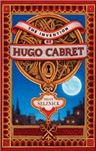  The Invention of Hugo Cabret  Brian Selznick |  | 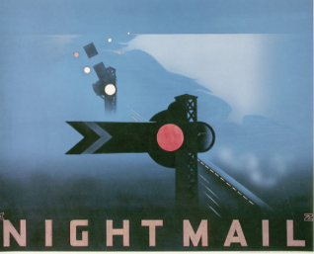  Night Mail
Outcomes | Own version narratives Diaries, explanations (sci experiment), dialogue, non chronological reports | Balanced discussions Research notes, non chronological reports in the form of a letter to a character
  Diaries, journalistic writing, flashback narratives, speeches, discussions, letters, film critiques | Letters, diaries, information leaflets, instructions
Theme/Term | Spring 1 |  | Spring 2
Planning Sequence/  Spelling Seed Text | 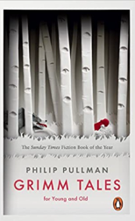  Grimm Tales | 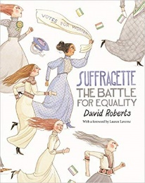  Suffragette: The Battle for Equality  David Roberts | 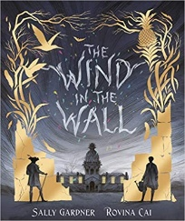  The Wind in the Wall  Sally Gardner | 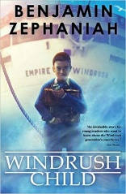  The Windrush Child  Benjamin Zephaniah
Outcomes | Retelling from a particular viewpoint, analyses, dialogue, own version traditional tale | Suffragette: The Battle for Equality  Persuasive campaigns Formal letters, diaries, balanced arguments, speeches, short news reports | Extended gothic novel Horror film poster, figurative writing, character/setting descriptions, old English letter, dialogue | Persuasive pitch to the local council Thought bubble, informal letter, poem, diary entry, advice, informal letter
Theme/Term | Summer 1  Fate vs. free will Summer 1 |  | Summer 2
Planning Sequence/  Spelling Seed Text | 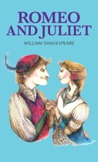  Romeo and Juliet  William Shakespeare |  | 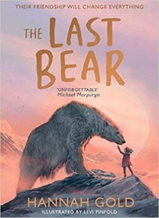  The Last Bear Hannah Gold
Outcomes | Playscripts  Diaries, letters, narratives, character descriptions, balanced arguments |  | Character profile, figurative descriptions, dialogue, monologue, l  ogbook entry, scientific report, newspaper article


