Theme/Term | Journeys & exploration Autumn 1 |  |  | Heroes & villains Autumn 2
Planning Sequence/  Spelling Seed Text | 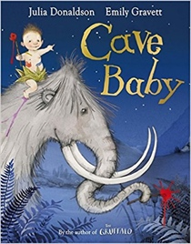  Cave Baby  Julia Donaldson and Emily Gravett | 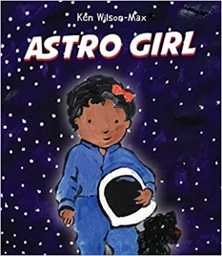  Astro Girl  Ken Wilson-Max |  | 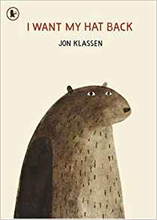  I Want My Hat Back  Jon Klassen | 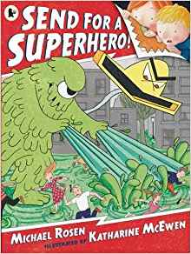  Send for a Superhero  Michael Rosen & Katharine McEwan
Outcomes | Narrative retellings  Labels and captions, informal letters | Fact files about being astronauts  Writing in role, commands, ‘how to’ guides |  | Story sequels  Questions, speech bubbles, letters, lists | Own version superhero narratives  Wanted posters, letters, speech bubbles, diaries, emails, character descriptions
Theme/Term | Similarities & differences Spring 1 |  |  | Nature & environment Spring 2
Planning Sequence/  Spelling Seed Text | 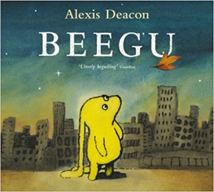  Beegu  Alexis Deacon |  | 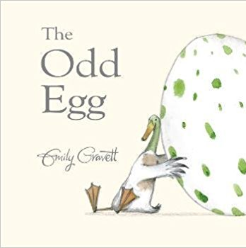  The Odd Egg  Emily Gravett | 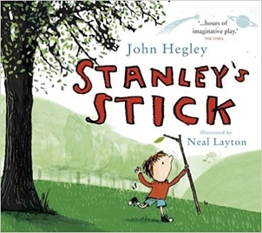  Stanley’s Stick  John Hegley and Neal Layton | Dinosaurs and all that Rubbish  Michael Foreman  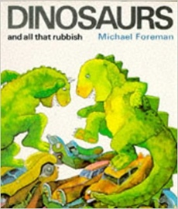  History: Changes within Living Memory
Outcomes | Own version ‘alien’ narratives  Descriptions, commands, letters, nonsense-word dictionary, poems, non-fiction reports |  | Egg-spotter’s guides (non-fiction reports)  Thought and speech bubbles, diaries, letter, certificate | Own version narratives  Retellings, descriptions | Pamphlets  Letters, setting descriptions, instructions, narrative retellings, pamphlets, posters
Theme/Term | Friendship & kindness Summer 1 |  |  | Imagination & creativity Summer 2
Planning Sequence/  Spelling Seed Text | 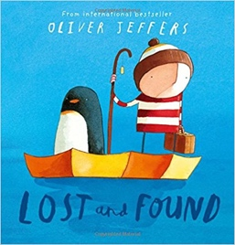  Lost and Found  Oliver Jeffers |  | 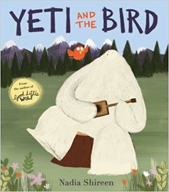  Yeti and the Bird  Nadia Shireen | 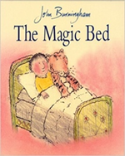  The Magic Bed  John Burningham | 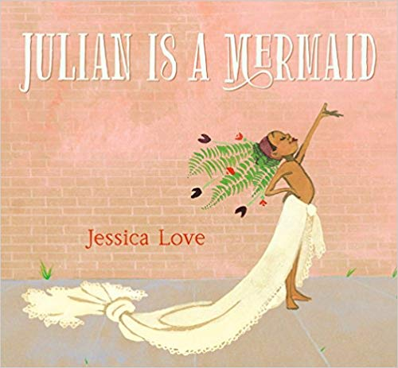  Julian is a Mermaid  Jessica Love
Outcomes | Own version ‘losing/finding’ narratives  Character descriptions, retellings, advice, instructions, non-chronological reports |  | Own version narratives about unlikely friendships  List of rules, letters, postcards, character descriptions | Own version fantasy stories  Setting descriptions, additional scenes, description of magical piece of furniture, lists | Own version fantasy stories  Setting descriptions, additional scenes, description of magical piece of furniture, lists  Three-verse poems  Instructions, writing in role, advertisements

