Theme/Term | A twist in the tale Autumn 1 |  |  | Creation & conservation Autumn 2
Planning Sequence/  Spelling Seed Text | 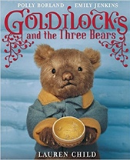  Goldilocks & Just the One Bear  Leigh Hodgkinson |  |  | 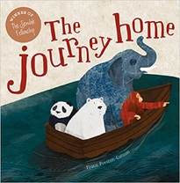  The Journey Home  Frann Preston-Gannon | 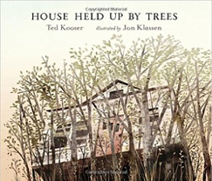  House Held Up By Trees  Ted Kooser
Outcomes | Sequel stories  Wanted posters, letters, retellings from another point of view, lists of rules, character descriptions |  |  | Persuasive letters  Posters, lists, postcards, wanted posters, information reports, short stories | News reports  Descriptive non-fiction, life-cycles, instructions for seed packets
Theme/Term | Bravery vs. fear Spring 1 |  |  | Change & relationships Spring 2
Planning Sequence/  Spelling Seed Text | 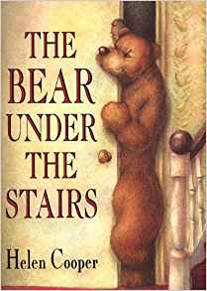  The Bear Under the Stairs  Helen Cooper | 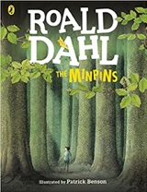  The Minpins  Roald Dahl |  | 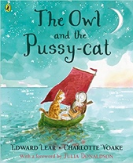  The Owl and the Pussy-cat  Edward Lear | 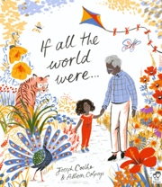  If All the World Were…  Joseph Coelho
Outcomes | Information texts  Letters, retellings, own version narratives | Own version adventure narratives  Danger posters, setting descriptions, character descriptions, information reports, postcards |  | Rhyming poems  Letters, interviews, lists, instructions | Non-narrative poems  Writing in role, diaries, letters of advice, short explanations
Theme/Term | A Twist in the tale Summer 1 |  | Fictional worlds & Fantasy Summer 1 | Urban Metropolis Summer 2
Planning Sequence/  Spelling Seed Text | Wolves  Emily Gravett  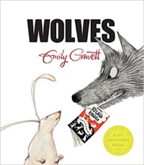 | 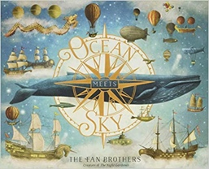  Ocean Meets Sky  Eric Fan and Terry Fan |  | 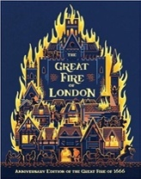  The Great Fire of London  Emma Adams | 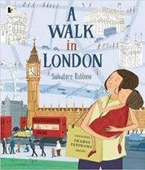  A Walk in London  Salvatore Rubbino
Outcomes | Non-chronological leaflets  Captions, information writing, character descriptions and comparisons | Own version fantasy world narratives  Setting & character descriptions, labels, diaries, postcards, captain’s logs, instructions, dialogue |  | Diary entries in role as the cat  Non- fiction texts incorporating a guide to London buildings, warning posters, writing in role | A Walk in…’ guidebooks  Recounts of a trip around the local area, statements of information

