 | Autumn Term |  | Spring Term |  | Summer Term
 | Term 1 | Term 2 | Term 3 | Term 4 | Term 5 | Term 6
ENGLIS | ,  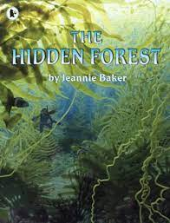  The Hidden Forest  Balanced discussions  Research notes, non-chronological reports in the form of a letter to a character  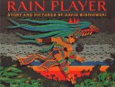  Rain Player  Instructions, poster, missing scene, diary, newspaper, debate Essay about The Maya | 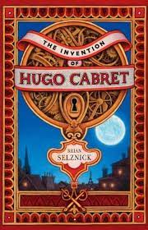  The Invention of Hugo Cabret  Biographies  Diaries, journalistic writing, flashback narratives, speeches, discussions, letters, film critiques |   The Windrush Child  Persuasive pitch to the local council Thought bubble, informal letter, poem, diary entry, advice, informal letter  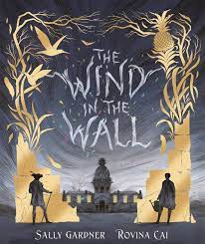  The Wind in the Wall  Extended gothic novel Horror film poster, figurative writing, character/setting descriptions, old English letter, dialogue | 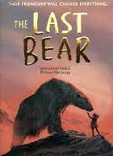  The Last Bear  Character profile, figurative descriptions, dialogue, monologue, logbook entry, scientific report, newspaper article | 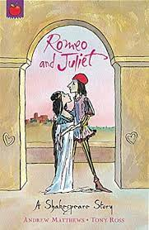  Romeo and Juliet  Playscripts Diaries, letters, narratives, character descriptions, balanced arguments | 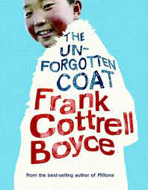  The Unforgotten Coat  Own version narratives  Diaries, explanations (sci experiment), dialogue
MATHS | Place value, Fractions, addition, Shape and Measures, Algebra Division, fractions and Measures Decimals, Subtraction and Percentages |  | Place value, Addition and subtraction, Multiplication of decimals, Statistics and data, fractions, Co ordinates, 2D shape , angles, Geometry, Multiplication and division. |  | Place value and decimals , fractions and ratio, Revision of Multiplication 2D shape, time and division , angles, Application of skills, Mathematical ideas
SCIENCE | Classification | Electricity | Animals including Humans | Light | Evolution and Inheritance
RE | Story of People of God.  Followers of Christ. | Advent.  Christmas | Baptism and Confirmation Celebrations  Lent | Holy Week  Prayers in The lives of the Followers of God | Easter  Pentecost | Belonging to Church Community  Celebrating the Life of Mary and the Saints
HISTORY | WW II |  |  | Crime and Punishment |  | Local Study – Stonor
GEOGRAPHY |  | Extreme Earth | The Americas |  | The United Kingdom
ART / DT | Drawing and pastels  Painting | Printing | Collage | Painting | D.T. Wood work
MUSIC | Ukelele
MUSIC | Composing |  | Appreciation |  | Great composers
COMPUTING | Computing Systems &amp; Creating Media  Networks (including Web page creation  E Safety)  Communication &amp;  Collaboration |  | Programming A  Variables in games | Data &amp; Information  Introduction to  spreadsheets | Creating Media Programming  3D Modelling Sensing Movement
PSHE | Created and loved by God |  | Created to love others |  | Created to love others | Created to live in community
PE | Basketball  Athletics | Football  Netball | ABC fitness  Dance | Hockey  Rugby | Tennis  Gymnastics/Futsal | Cricket Rounders  Sports day events  Athletics & races
MFL | Days of Week/ months | Food Glorious food | Weather | Colours/Numbers | Body Parts

