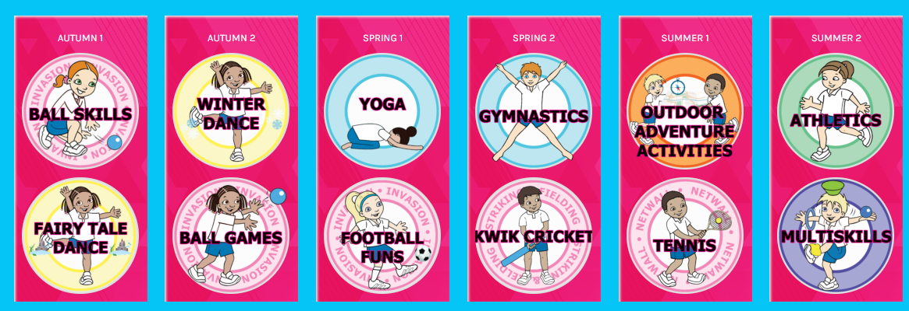
Sacred Heart Year 1 / 2
PE Yearly Overview

