Theme/Term | Autumn 1 |  | Autumn 2
Planning Sequence/  Spelling Seed Text | Beowulf  Michael Morpurgo 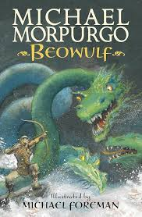 | Hidden Figures  Margot Lee Shetterley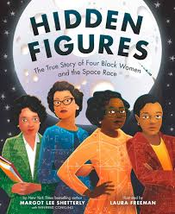 | Percy Jackson  Rick Riordan 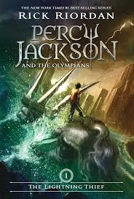
Outcomes | Letter of advice, diary entry, dialogue, character and setting description, action scenes, obituary | Non-chronological reports, job adverts, formal persuasive letters, informal letters, diary entries, character descriptions, opinion pieces
  Poetry in the form of an ode, soliloquy, setting descriptions, diary entries, additional chapter, non-chronological reports
Theme/Term | Spring 1 |  | Spring 2
Planning Sequence/  Spelling Seed Text | The Lost Thing  Shaun Tan 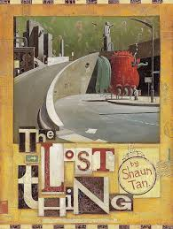 | High Rise Mystery  Sharna Jackson 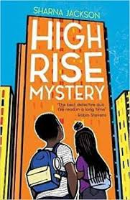 | Robot Girl  Malorie Blackman 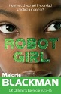 | The Lost Happy Endings  Carol Anne Duffy 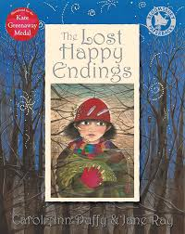
Outcomes | Diary entries, formal letters,adverts,character and setting descriptions, non-chronological reports | Character Description, Police Report, Setting Description, Newspaper Article, Dialogue, Formal Persuasive Letter, Extended Narrative | Discussion / debate, character comparisons, dialogue, email in role, setting description, advice letter, action scene, book review | Letter, poetry, passage of direct speech, diary entry, story ending
Theme/Term | Summer 1  Fate vs. free will Summer 1 |  | Summer 2
Planning Sequence/  Spelling Seed Text | Kaspar  Michael Morpurgo 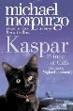 |  | Curiosity  Markus Motum 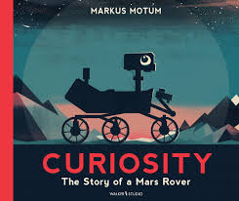 JT Williams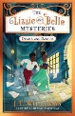 | Lizzie & Belle Mysteries 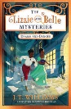  JT Williams
Outcomes | Character descriptions, reports, letters, advertising leaflet, balanced report |  | Proposal to NASA, information labels, short explanation, NASA log of Mars landing, news report  Posters, diary entries, case notes, letters, dialogue (quotations), character descriptions, fact files, persuasive speeches


