
Sacred Heart Primary School Year Group Overview: Year 5

 | Autumn Term |  |  |  |  |  | Spring Term |  |  |  |  |  | Summer Term
 | Term 1 |  | Term 2 |  |  |  | Term 3 |  | Term 4 |  |  |  | Term 5 |  |  | Term 6
MATHS | Place Value  Addition & Subtraction |  |  | Multiplication & Division  Fractions |  |  | Multiplication & Division  Fractions |  |  |  | Decimals & Percentages  Perimeter & Area  Statistics |  | Shape  Position & Direction  Decimals |  | Negative Numbers  Converting Units  Volume
ENGLISH  Writing Root | 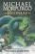Beowulf  Michael Morpurgo | 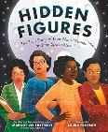  Hidden Figures  Margot Lee Shetterly |  | 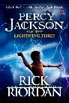  Percy Jackson  Rick Riordan |  | 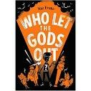  Who Let The Gods Out  Maz Evans | 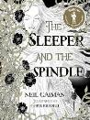  The Sleeper and the Spindle  Neil Gaiman | 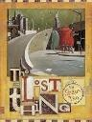  The Lost Thing  Shaun Tan |  |  | 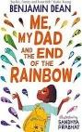  Me, My Dad & the end of the Rainbow  Benjamin Dean | 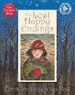  The Lost Happy Endings  Carol Ann Duffy | 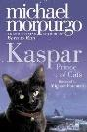  Kaspar  Michael Morpurgo | 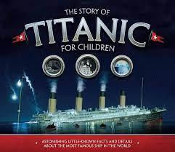  The Story of the Titanic  Joe Fullman | 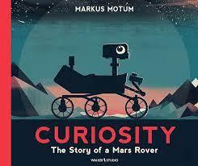  Curiosity  Markus Motum |  | 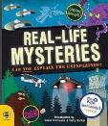  Real Life Mysteries  Susan Martineau
ENGLISH  Literary Leaf | 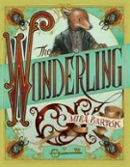  The Wonderling  Mira Bartok |  |  |  | 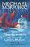  Sir Gawain & the Green Knight  Michael Morpurgo |  | 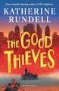 The Good Thieves  Katherine Rundell |  |  |  |  |  | 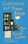 Overheard in a Tower Block  Joseph Coelho
HISTORY | The Vikings |  |  |  |  |  | The Victorians |  |  |  |  |  | Local History
GEOGRAPHY | Enough For Everyone |  |  |  |  |  | Exploring Eastern Europe |  |  |  |  |  | The United Kingdom
SCIENCE | Living Things and their Habitats-Plants |  |  | Properties and Changes of Materials |  |  | Animals including Humans |  |  |  | Earth and space |  | Forces |  | Scientists and Inventors
ART/DT | Drawing  (Viking Art) |  | Textiles:  Stuffed Toys  DT |  |  |  | Painting and mixed media: Portraits |  |  | Craft and Design  ( architecture)  Art |  |  | Bridges |  | Cooking and nutrition: Developing a recipe  DT
MUSIC | Ukulele and Christmas Nativity songs |  |  |  |  |  | Ukulele and ‘The Blues’ |  |  |  |  |  | Ukulele and Musical Theatre
FRENCH | All Around Town |  |  |  |  |  | That’s Tasty |  |  |  |  |  | School Life
COMPUTING | Computer systems & networks |  |  | Creating media |  |  | Programming A |  |  |  | Data & Information |  | Creating Media |  | Programming
RE | Creation  Miracles & Sacrament of the sick |  |  | Advent  Parables |  |  | Christmas  Baptism |  |  |  | Lent  Holy Week |  | Easter  Pentecost |  | Work of the apostles  Marriage & Holy Orders

