Theme/Term | Magic & wonder Autumn 1 |  |  |  |  | Dreams & curiosity Autumn 2
Writing Root /  Spelling Seed Text | 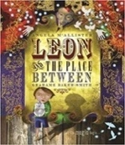  Leon and the Place Between  Angela McAllister | 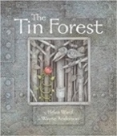  The Tin Forest  Helen Ward | 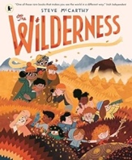  The Wilderness  Steve McCarthy | 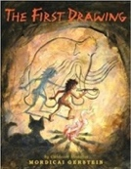  The First Drawing  Mordicai Gerstein |  | 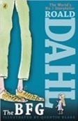  The BFG  Roald Dahl | 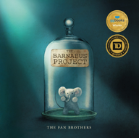  The Barnabus Project  The Fan Brothers |  | 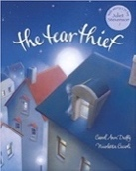  The Tear Thief  Carol Ann Duffy |  | 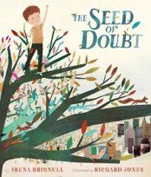  The Seed of Doubt  Irena Brignull
Length | 15 sessions, 3 weeks | 15 sessions, 3 weeks | 15 sessions, 3 weeks | 10 sessions, 2 weeks |  | 15 sessions, 3 weeks | 15 sessions, 3 weeks |  | 15 sessions, 3 weeks |  | 15 sessions, 3 weeks
Outcomes | Own version fantasy narratives  Persuasive posters, setting descriptions, thought bubbles/diaries, dialogue | Persuasive information leaflets Persuasive posters, information leaflets, postcards, diaries, wishes, setting descriptions | Guide to the wilderness  ‘Meet the family’ introduction, letter of advice, poem, SOS message, identification label | Own historical narratives  Character descriptions, diaries, recounts |  | Own version fantasy narratives Recount (diary entry), character descriptions, wanted posters, new chapters, instructions | Brochures  Instructional writing (escape plan, experiment), descriptions, advertisements, letters of advice, dialogue |  | Newspaper article  Shared poems, diary entries, persuasive posters, letters of explanation, discussions |  | Motivational leaflet  Shared poems, dreams and aspirations, setting descriptions, advice letters, paper aeroplane messages, speeches
Literary Leaf Text | 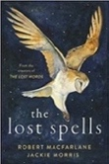  The Lost Spells  Robert MacFarlane |  | 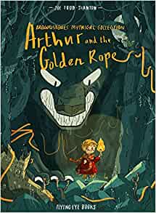  Arthur and the Golden Rope  Joe Todd Stanton |  | History: Vikings |   The BFG  Roald Dahl |  |  | 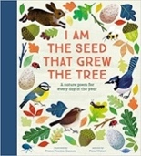  I am the Seed that Grew the Tree  Fiona Waters
Length | 10 sessions, 2 weeks |  | 15 sessions, 3 weeks |  |  | 15 Sessions, 3 weeks |  |  | 12 Sessions, 2+ weeks
Theme/Term | Hope & resilience Spring 1 |  |  |  |  | Inspiration and strength Spring 2
Writing Root /  Spelling Seed Text | 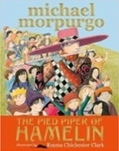  The Pied Piper of Hamelin  Michael Morpurgo | 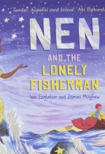  Nen and the Lonely Fisherman  Ian Eagleton | 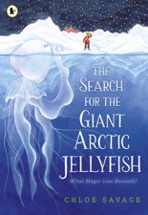  The Search for the Giant Arctic Jellyfish  Chloe Savage | 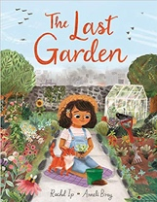  The Last Garden  Rachel Ip |  | 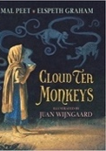  Cloud Tea Monkeys  Mal Peet & Elspeth Graham | 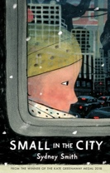  Small in the City by Sydney Smith |  | 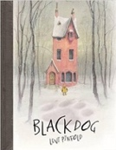  Black Dog  Levi Pinfold |  | 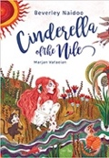  Cinderella of the Nile by Beverley Naidoo
Length | 15 sessions, 3 weeks | 15 sessions, 3 weeks | 10 sessions, 2 weeks | 15 Sessions, 3 weeks |  | 15 sessions, 3 weeks | 15 sessions, 3 weeks |  | 15 sessions, 3 weeks |  | 15 sessions, 3 weeks
Outcomes | Own version myths/legends  Writing in role, information reports, adverts, formal letters | Own version narrative  Lonely hearts advert character description, diary entries, message in a bottle | Non-chronological report  Video messages, letters, diary entries, poetry, speech bubbles | Own version extended narrative  Setting descriptions, advertisement/ poster, retelling, instructional flyer, social media updates, dialogue |  | Non-chronological reports Descriptions, ‘how to’ guides (instructions), letters, discussions | Extended narrative from an alternative point of view  Setting description, poem, diary entry, dialogue, letter of advice, lost poster |  | Own version ‘suspense’ narratives  Postcards, dialogue, retellings, descriptions |  | Own version narratives  Descriptive passages, how to guides, letters, discussions, non-chronological reports
Literary Leaf Text | 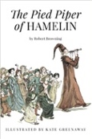  The Pied Piper of Hamelin  Robert Browning |  | Mr Penguin and the Lost Treasure  Alex T. Smith   |  | Science: Volcanoes | 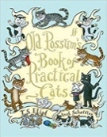  Old Possum’s Book of Practical Cats  T. S. Eliot |  |   Africa, Amazing Africa  Atinuke |  | 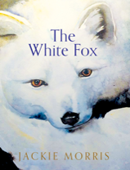  The White Fox  Jackie Morris
Length | 10 sessions, 2 weeks |  | 15 Sessions, 3 weeks |  |  | 12 sessions, 2+ weeks |  | 15 Sessions, 3 weeks |  | 15 Sessions, 3 weeks
Theme/Term | From mystery to discovery Summer 1 |  |  |  |  | Confidence & caution Summer 2
Writing Root /  Spelling Seed Text | 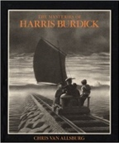  The Mysteries of Harris Burdick  Chris Van Allsberg | Escape from Pompeii  Christina Balit  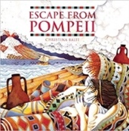 | 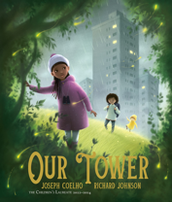  Our Tower  Joseph Coelho | 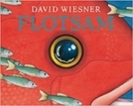  Flotsam  David Wiesner |  | 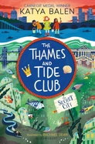  The Thames and Tide Club  Katya Balen | 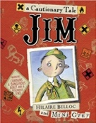  Jim, A Cautionary Tale  Hilaire Belloc |  | 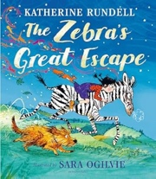  The Zebra’s Great Escape  Catherine Rundell |  | 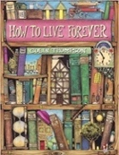  How to Live Forever  Colin Thompson
Length | 15 sessions, 3 weeks | 16 sessions, 3+ weeks | 15 sessions, 3 weeks | 15 sessions, 3 weeks |  | 15 sessions, 3 weeks | 15 sessions, 3 weeks |  | 15 sessions, 3 weeks |  | 15 sessions, 3 weeks
Outcomes | Extended fantasy narrative  Setting description, short first person narrative, dialogue, speech, action scene | Newspaper reports  Setting descriptions, diaries, letters, thought bubbles | Extended fantasy narratives  Poems, setting descriptions, diary entries, dialogue, letters of thanks | Sequels (mystery narratives)  Postcards, setting descriptions, non- chronological reports, message in a bottle letters |  | Own version fantasy narrative Persuasive letters and letters of advice, diary entries, weather reports, advertisements, dialogue | Narrative poems  Warning posters, warning announcements, alternative endings, performance poetry, letters of apologY |  | Own version 'great escape' narrative Wanted poster, letter, action scene, poetry, dialogue |  | Prequels Lost posters, dialogue, setting and character descriptions, ledger entries, instructions, letters of warning
Literary Leaf Text | 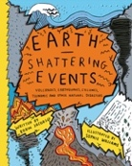  Earth Shattering Events  Robin Jacobs |  | 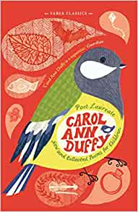  New and Collected Poems for Children  Carol Ann Duffy |  |  | 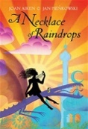  A Necklace of Raindrops  Joan Aiken |  |  | 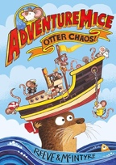  Adventuremice: Otter Chaos  Philip Reeve & Sarah McIntyre
Length | 15 sessions, 3 weeks |  | 10 Sessions, 2 weeks |  |  | 14 sessions, 2+ weeks |  |  | 12 Sessions, 2+ weeks

