Sacred Heart PE Long Term Overview

Reception

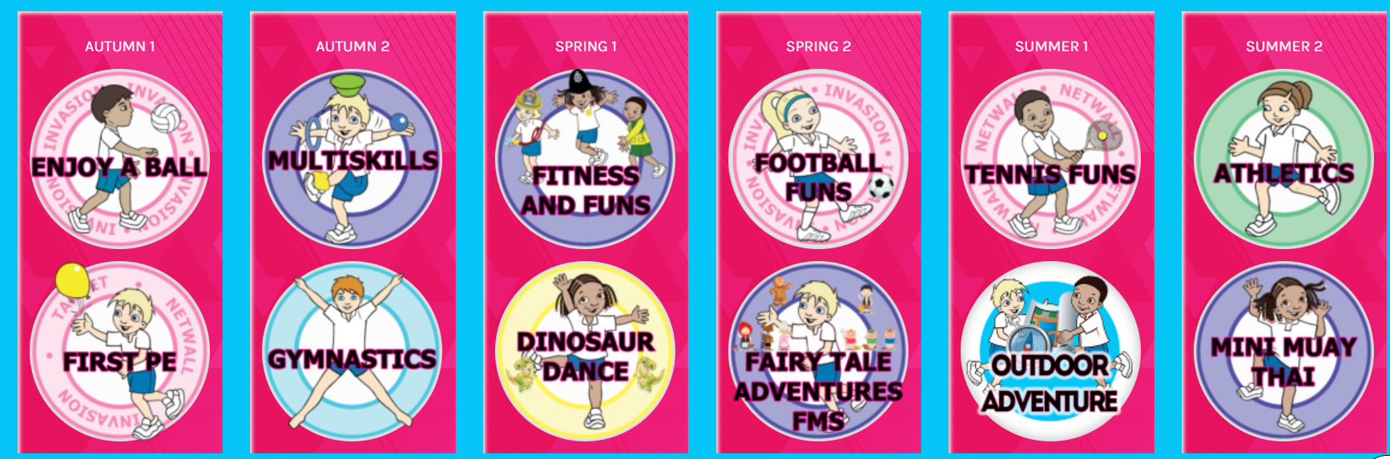

Year 1

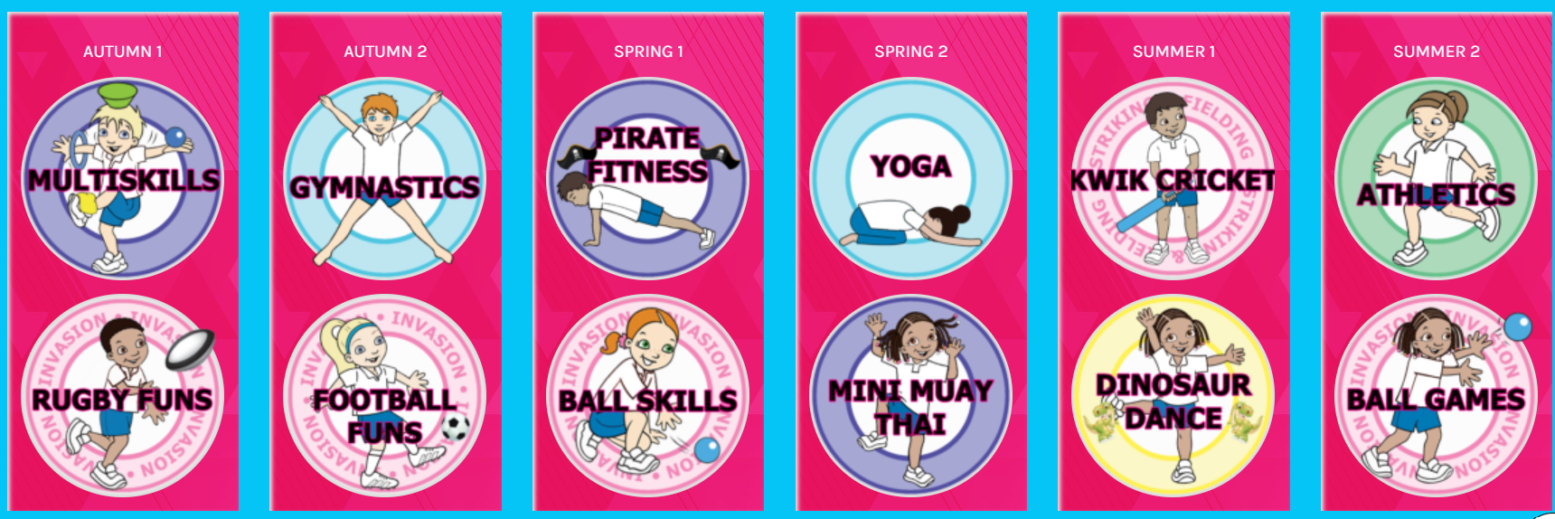

Year 2/3

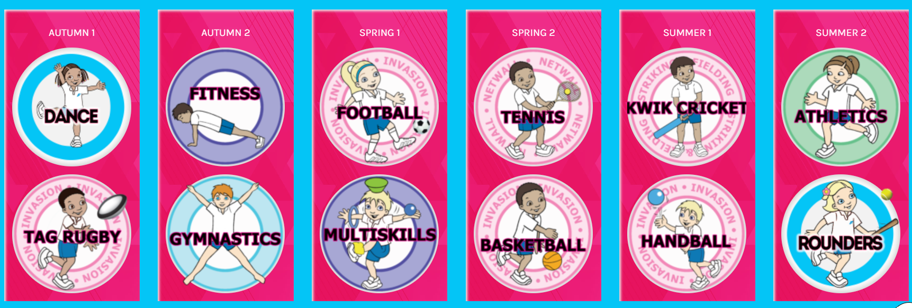

Year 4/5

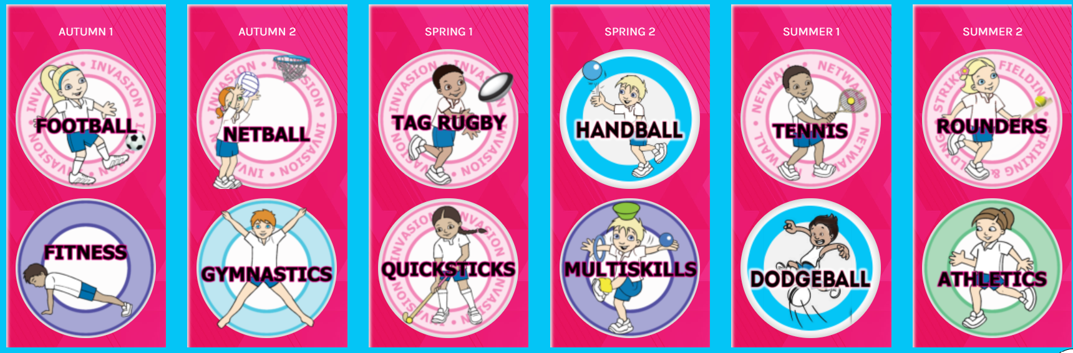

Year 6

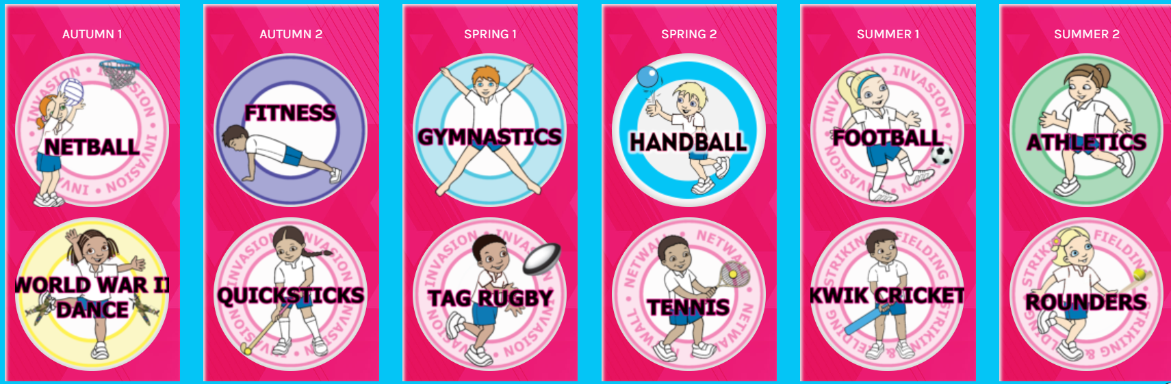



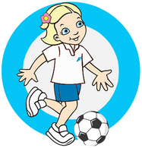
P ROGRESSION OF KEY SKILLS

Football
Y
Early Years E
Explore stopping a ball with different parts of the body
Experiment kicking the ball with feet to a partner
Move a bean bag/ball on the floor using inside of foot
Fox and rabbits game. Object of the game is to move away from the rabbit onto a spot (finding a space)
Shooting into a target on the floor
Introducing fun games e.g. Player in the middle, defending hoops (beginnings of attacking, defending)

1
Year 1
Stopping a ball with the inside of feet
Pass the ball, beginning to use inside of feet “toe, toe, toe, no, no, no!”
Dribble the ball with the inside of feet -finding a space
Introduce getting the ball off a player- tackling
Scoring in a variety of ways- into goals and at targets
Begin to understand tactics for attacking and defending
Small sided games 4v4

2
Year 2
Stopping a ball with the sole and inside of feet
Pass the ball to a partner P,P,P, Plant, Pass Point to help with accuracule
Dribble the ball with the inside of feet, keeping the ball close to their body- dribble into a space
Improve tackling by using adapted games- introduce intercepting play
Scoring in a variety of ways and begin to use in a game situation
Begin to include some basic tactics for attacking and defending in conditioned games
Play an adapted and conditioned games 5v5.

3
Year 3
Control a ball using inside, outside and sole of feet
Pass the ball with inside of feet with accuracy. Pass the ball to someone in a space
Dribble the ball, beginning to turn with some control (inside and outside hook)
Defend making a tackle in isolation (a conditioned game)
Shooting - Kick a stationary ball past a goal keeper
Adapted games, begin to apply some basic principles for attacking & defending in small sided games
Small sided games 6v6

Year 4
4
Move body to correct position to stop and control a ball
Pass the ball with inside of feet, whist on the move
Dribble the ball using inside, outside hook and drag back, beginning to accelerate
Defend- moving forward to close down space to tackle in a conditioned game. Intercept a pass
Shooting- Strike a moving ball (past a goal keeper) with some accuracy
Encourage children to talk about tactics when attacking and defending
Small sided games - up to 7v7

5 Year 5
Control the ball using either foot when moving Pass the ball with inside, front or laces on the foot
Dribble the ball using inside, outside hook and drag back beginning to accelerate Show good body position to defend and press in a 2v2 game
Scoring using top of foot (laces)- aiming for corners of the goal
Begin to use attacking and defending, techniques learned in a game situation
In teams, begin to discuss tactics and how to work as a team (communicate and collaborate)

Year 6 6
Move into space to receive the ball and control with either foot in a game Select the correct pass for various distances in a game situation
Dribble the ball in a game situation around a defender
Communicate with team when defending in a game -making interceptions, cover space To work as a team to score, shooting from various angles
In a team, discuss tactics and how to win as a team (communicate and collaborate)
Use techniques learned and apply in a game situation. Apply basic principles for attacking and defending Understanding the positions and rules of the game


P ROGRESSION OF KEY SKILLS
Fitness
Y

Early Years E
Experiment with different ways of balancing through various fun exercises
Imaginative exercises beginning to count how many they can do
Begin to co-ordinate different parts of your body through fun exercises
Begin to understand the importance of good health, physical exercise, and a healthy diet

1
Year 1
Balance on different parts of body performing static and some moving exercises Each imaginative exercise - encourage to count score and record them
Co-ordinating body whilst beginning to move with control when exercising Beginning to understand what is happening to your body when exercising

2
Year 2
Balancing in exercises static and when moving building control when performing movements
Counting scores, recording them and trying to beat their score
Co-ordinating body whilst beginning to move at different speeds during various exercises
Understand what is happening to your body when exercising and how to feel a pulse

3
Year 3
Balancing with control, focusing on preferred and non preferred leg (when performing exercises) Complete a variety of fitnes exercises successfully and achieve a personal best
Co-ordinate body to perform a combination of movements in a variety of exercises
Take pulse before exercise. Understand how your body is getting stronger when exercising
Year 4
Balancing in different directions e.g. on leg- foward backward and side to side
Complete a variety of fitness activities confidently and achieve a number of personal bests
Co-ordinate body efficiently to perform a combination of movements or actions when exercisng Begin to know different types of fitness. Take pulse before and after exercise
4

5 Year 5
Balancing on various parts of body when moving -using core strenghth and keeping control when moving
Can compare their performances with previous ones and strive to achieve a personal best on each station
Co-ordinate using both sides of the body when performing exercises - increasing speed and power
Create a warm up and cool down. Take pulse before and after exercise accurately

Year 6  Balance on various body parts using harder balances e.g shutting eyes, adding explosive movements | 6
Evaluate previous performance levels and demonstrate improvements to achieve their personal best | 6
Co-ordinate using both sides of the body with fluency and speed to perform a combination of exercises
Create an exercise to improve a specific fitness e.g. strength, co-ordintation, power

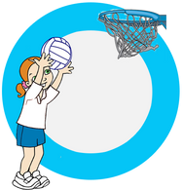
P ROGRESSION OF KEY SKILLS

Netball
Y
Early Years (progressions through first PE unit/Enjoy-a-ball) E
Throw to self, catching a soft ball/balloon
Experiment with rolling the ball, throw and catch to self and to a partner (hand-eye co-ordination)
Moving around, changing direction and negotiating space
Fun games, encouraging throwing and catching different types of ball
Passing with a partner and counting to 5 and 10
Shooting into a target or hoop on the floor
Introducing fun games e.g. Player in the middle, defending hoops (beginnings of attacking, defending)

1
Year 1 (progressions through ball skills/ball games)
Catch a soft ball safely. Pass a soft ball from the chest – ‘W’ shape when passing and receiving
Adapted game introducing footwork- no running with the ball
Move into a space in a game, looking to throw the ball to someone in a space
Follow an opponent in a game/adapted game
Scoring in a variety of ways- into hoops and targets
Begin to develop tactics for attacking and defending.
Small sided games (super hero ball) 3 v 3

2
Year 2 (progressions through ball skills/ball games)
Introduce a bounce pass from a short distance to a partner
Adapted games -Feet are stuck when receiving the ball - developing thought process of footwork rule
Move into a space to catch a ball. Pass the ball to someone in a space
Follow an opponent and trying to win (intercept) the ball
Scoring in a variety of ways and begin to use in a game situation
Develop tactics for attacking and defending
Play an adapted super hero netball game.

3
Year 3
Pass and receive a netball safely (chest and bounce pass). Pass the ball in a game within 4 seconds
Perform a stride and jump stop in netball
Perform a dodge in netball to get into a space
Marking a player, keeping on the balls of your feet
Shooting the ball high and bending knees-into hoop/target
Adapted games, begin to apply some basic principles for attacking & defending
Introduce Bee netball (Flier)

Year 4
4
Pass and receive, stepping into the pass with control (chest, bounce and shoulder pass)
Perform a stride and jump stop with a pivot
Perform two different dodges (Drive and the dodge) creating space to receive the ball
Marking a player, standing side on, sticking to player
Shooting- focus on bending the knees and place hand under the ball to shoot
Encourage children to talk about tactics when attacking and defending
Confidently play Bee netball (Flier) 4v 4

5 Year 5
Selecting the correct pass in a game and move into a space
Receive the ball on the move and perform the correct footwork (jump stop, stride stop and pivot
Perform three different dodges (Drive dodge and double dodge)and receive a ball in a space
To defend a player and attempt to intercept a pass
Shooting into netball posts - Stance, bend knees to gain height, flick wrist for accuracy
Begin to use attacking and defending, techniques learned in a game situation
Begin to understand the positions in a Bee Netball (Stinger) game
In teams, begin to discuss tactics and how to work as a team (communicate and collaborate)

Year 6 6
Perform a variety of passes with some precision - quickly move into a space to receive another pass Perform correct footwork in a game - pivoting to turn the correct way to pass the ball
Perform a variety of dodges to move into a space and receive a ball - in a practice and in a game situation Defend a player during a game, intercepting the ball
Shoot into a netball post, focus on precision and accuracy and attempt to get the rebound if the shot is missed In a team, discuss tactics and how to win as a team (communicate and collaborate)
Use techniques learned and apply in a game situation. Apply basic principles for attacking and defending
Play Bee Neball (Stinger) -understanding the positions and rules

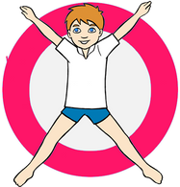
P ROGRESSION OF KEY SKILLS

Gymnastics
Y
Early Years E
Can experiment with different shapes
Experiment with different jumps
Experiment with different ways of rolling in small shape
Experiment with balancing on different body parts
Moving along the floor in different ways like aliens sliding, rolling, stretching etc
Show a start shape, middle and finishing shape (beginning of a sequence)
Moving on and off apparatus safely

1
Year 1
Can perform various shapes
Perform basic jump (straight jump, Star jump
Perform a tuck rock and a tuck roll and rocket roll with pointed toes
Perform a simple balance holding for 3 seconds
Perform a bunny hop- hands first then feet
Perform a basic sequence (roll, jump and roll)
Moving on and off apparatus with control

2
Year 2
Can perform shapes with a strong body and control
Perform jumps (straight, star, tuck jump) with control and a strong body
Perform a tuck rock, tuck roll, forward roll and dish/arch roll
Perform a balance on one or more parts of body
Perform a bunny hop – hands flat with straight arms
Perform a sequence on apparatus– (roll, jump and balance)
Moving on and off apparatus with strong body and control

3
Year 3
Can perform a variety of shapes with good control
Perform a straight jump with a half turn
Perform a Teddy bear roll
Perform Point and Patch balances
Perform a bunny hop across a mat run and onto/across low benches and apparatus
Perform a short sequence on mats (using levels directions control)
Hopscotch on throw down feet- introduction to hurdle step onto apparatus

4
Year 4
Can perform a variety of shapes with good control when performing various skills
Perform various jumps and develop travelling across the mat
Teddy bear roll with a partner/group in sequence with pointed toes
Perform matching and mirroring balance routines on apparatus
Perform a bunny hop onto a variety of apparatus with control
Perform a short sequence on mats and apparatus showing levels,unison, and pointed toes
Hopscotch across the floor to develop hurdle step onto low apparatus

5 Year 5
Can perform complex shapes with control and some flexibility
Perform more complex jumps, tuck, pike and a scissor kick
Perform a T-roll
Perform symmetrical and asymmetrical balances
Perform a ‘squat on and squat off’ on various apparatus
Link skills to create a sequence with Fluency. Co-operate, communicate and collaborate with others
To perform a hurdle step on the floor/springboard
Cartwheel on the floor using various apparatus

Year 6 6
Can perform complex shapes when performing Sequences and skills with flexibility
Perform more complex jumps and travelling on and off apparatus, tuck, pike and leaps scissor kick and cat leap Side star roll, T-roll (with pointed toes), backwards roll
Perform various balances counter balance and counter tension
Perform a ‘squat on and squat off ‘apparatus with a run up (with or without a spring board) Compete in teams to win points with sequences and a vault competition
Perform a hurdle step on the floor/springboard and onto apparatus Inverted skills shoulder stand, cartwheel, teddy bear roll, head stand, handstand

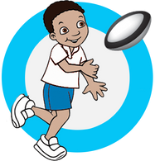
P ROGRESSION OF KEY SKILLS

Tag Rugby
Y
Early Years E
Follow a partner to steal their bib - introducing tag games
Move with different objects in their hands
Passing an object to another child
Trying to get around a static player in a coned area
Scoring points with beanbag treasure in a simple hoop invasion game
Fun game getting past the fish (defender) in a small area. Fish (defender) trying to get the tails

1 Year 1
Play a simple game of tag and begin to call 'tag' when taking a bib or belt Hold the ball with two hands
Hand over the Rugby ball sideways Attempt to get past a defender 1v1
Scoring a try in a modified drill using correct technique- using 2 hands to place ball down Small-sided adapted games. Begin to develop tactics for attacking and defending

2
Year 2
Tag a player when facing your partner - raise hand and call "Tag"
Move with the ball, holding it with hands- chest height
Pass the ball sideways- with smile technique
Dodge around a defender in a small area
Scoring a try in an adapted game- focus placing ball down with 2 hands and staying on feet
Small-sided games using various types of equipment. Develop tactics for attacking and defending

3 Year 3
Tag another player, face on and keeping body position low to the ground
Move with a ball in their hands using correct position
Pass the ball backwards and sideways in isolation
Move into a space to avoid a defender, through dodging techniques
Beat a defender to score a try in various scoring zones
Adapted games, with variations of rules, begin to apply some basic principles for attacking & defending

4
Year 4
Play a tag game whilst moving at speed, keeping close to an opponent
Move with control in a variety of directions holding the ball in the correct position
Pass the ball backwards/ sideways with control whist moving
Use speed and space to avoid a passive defender
Beat a defender at speed to score a try in an isolated game situation
Play adapted games, Children encouraged to think of tactics when attacking and defending

5 Year 5
Tag more than one player using either hand whilst moving
Choose different pathways to move with a ball in hands against an opponent
Pass the ball and move (loop around a teammate)
Introduce looping around your teammate- to try and trick an opponent
Working as a team to score a try- supporting runs in practice
Developing tactics for attacking e.g working as a team, supporting each other
In teams discuss tactics of attacking e.g diagonal line when attacking
In a team, discuss tactics of defending e.g make a wall or flat line as a team when defending

Year 6 6
Tag a player using either hand when moving at full speed in a game situation
Dodge around a defender at speed with a ball in hands avoiding being tagged Bring in pass and loop into a game situation
Looping around your teammate- to try and trick an opponent in game situation
Working together as a team to score a try in a tag rugby game, e.g supporting diagonal runs
Use techniques learned and apply in a game situation. Apply basic principles for attacking and defending In a team, discuss tactics of attacking and defending (communicate and collaborate)

ROGRESSION OF KEY SKILLS
P

Hockey (Quicksticks)

Early Years
(progressions through first PE unit/Enjoy-a-ball) EY

Ball Awareness-moving the ball along the floor using hands Pushing/Patting the ball to a partner using one hand
Move around safely in a variety of ways and negotiating space
Trying to get the magic ball from another player-holding a throw down strip (magic wand) in hand Scoring into a target in a variety of ways
Play adapted games- beginning to score into a goal

1 Year 1
(progressions through Ball Games, tennis)

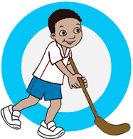
Ball Awareness-moving a ball along the floor using a tennis racket Pushing a ball to a partner using a hand paddle/tennis racket
Begin to move into a space in a 'Hand hockey' game holding throw down strips (in hand) Hand hockey-beginning to tackle, holding a throw down strip as extension to hand Introduce scoring into a goal, using various types of equipment
Small-sided adapted games 3v3. Begin to develop tactics for attacking and defending.
Year 2 (progressions through Ball games, tennis) 2
Ball Awareness-moving a ball along the floor with control, using a tennis racket Pushing a ball to a partner when using a tennis racket, developing control
Pass and begin to move forward into a space in a 'Hand hockey' game, holding a throw down strip (in hand) Hand Hockey-beginning to anticipate when to tackle, using throw down strips (as hand extension) Scoring into goals/targets using various types of equipment e.g. tennis racket to hit a ball through cones
Small-sided games using various types of equipment. Develop tactics for attacking and defending

3 Year 3
Dribble the ball holding the stick in correct position Pass and receive a ball with some control
Perform a pass and look for a space in an adatped game to recieve the ball
Begin to tackle a player safely- when stationary and moving
Score whilst the ball is stationary. Adapted games to focus on accuarcy
Adapted games, with variations of rules, begin to apply some basic principles for attacking & defending

4
Year 4
Dribble and stop the ball with control
Pass the ball over a longer distance with accuracy and power
Perform a short pass and begin to move into a space and receive the ball with some control
Tackle a player beginning to use the correct grip and positioning -bend knees, low to the ground.
Develop shooting - at targets/goals. Beginning to score whilst the ball is moving
Play adapted games, Children encouraged to think of tactics when attacking and defending

5
Year 5
Dribbling the ball in different directions, keeping head up
Pass the ball over a variety of distances with some accuracy and power, in a game situation
Perform a pass with some control, accuracy and with movement into a space
Begin to defend against an opponent in a game situation - tackling and marking
Hit a moving ball with some accuracy and control into a goal
Begin to use techniques learned in a game situation and to have an understanding of key rules

6
Year 6
Dribble the ball at various speeds- both in isolation and a game situation
Pass the ball over a variety of distances in attacking or defensive situations
Pass and move into a space with accuracy, control and speed (in isolation/game situation)
Begin to defend as an individual and communicate to defend as a team (marking and tackling)
Hit a moving ball into a goal from different angles and sometimes with different levels of power
Use techniques learned and apply in a game situation. Apply basic principles for attacking and defending

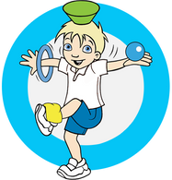
P ROGRESSION OF KEY SKILLS
Multi-Skills
Early Years
Experiment with different ways of balancing Experiment with different ways of moving (agility)
Experiment with different ways of moving ball with different body parts (co-ordination) Working with friends in a team-taking turns
EY
5

1
Year 1
Balance on lines with control and use equipment to balance on various parts of the body Changing direction with some control (agility)
Co-ordinating body whilst beginning to move with equipment
Co-operate, compete and challenge themselves as a team in various games

2
Year 2
Balance on low equipment with good control
Changing direction quickly with good balance and control (agility)
Co-ordinating body whilst beginning to move at different speeds with various equipment
Complete challenges as a team in various running/obstacle games and working to improve performance

3
Year 3
Balancing on various body parts while moving Agility focus -changing direction at speed
Co-ordinate body to perform a combination of movements
Complete a variety of fitness tests successfully and achieve a personal best
Year 4
Balancing confidently using various equipment and body parts Agility focus - changing direction at speed with good technique
Co-ordinate body efficiently to perform a combination of movements or actions Complete a variety of fitness tests confidently and achieve a number of personal bests
4

Year 5
In combination with different skills, can balance equipment while moving and co-ordinating another action
Agility focus – change direction quickly and efficiently with equipment
Agility focus – change direction quickly and efficiently with equipment
Test and measure balance, agility and co-ordination confidently and accurately. Can compare their
performances with previous ones and strive to achieve a personal best

Year 6  Balance equipment on various body parts whilst moving or co-ordinating another body actions accurately | 6
Agility focus – can change direction at speed with balance and control whilst using various equipment | 6
Co-ordinate using both sides of the body with fluency to perform a combination of movements or actions
Complete each test with fluency and accurately measure and record. Evaluate previous performance levels
and demonstrate improvements to achieve their personal best

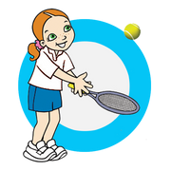
4
Early Years
EY
P ROGRESSION OF KEY SKILLS
Tennis
Throw and catch to self with a soft ball and to bounce catch to self
Balance an object e.g. beanbag on racket
Hand eye co-ordination passing ball to a partner
Move the ball on floor with hand in a variety of ways
Push ball with throw down strips to develop hand eye co-ordination

1
Year 1
Throwing and catching a small, ball improving control- bounce catch to self/ partner Balance a ball on racket
Hand eye co-ordination -tap ups (using a racket) watching the ball, knees bent Racket familiarisation- moving ball with racket in forehand/backhand position Introduce modified games - eg hand tennis
Small-sided adapted games. Begin to develop tactics in the adapted games

2
Year 2
Throw and catch from one hand to the other and bounce catch into a target with a partner
Balance a ball on racket with control
Increasing the control tapping ball to a partner (who is catching the ball)
Racket familiarisation- moving ball with racket in forehand and backhand position whilst moving
Play a modified game
Develop tactics for beating an opponent

3 Year 3
Move body position to catch a ball
Control a ball on racket when moving - varying speed
Hit a ball into a target (with one bounce)
Hit ball across the floor with forehand/backhand position
Play a modified game using skills e.g forehand
Adapted games, with variations of rules, begin to apply some basic principles

Year 4
Move with balance and control to catch a ball
Hit/bounce ball on racket when moving
Hit a ball into a target from a variety of distances/ angles with no bounce
Hit ball in forehand/ backhand position with drop feed
Play a game communicating as a team
Play adapted games, Children encouraged to think of tactics

5 Year 5
Move to hit a ball with some control
Hit/ bounce a ball with control when moving at different speeds
Serve diagonally with underarm/overarm throwing into target/game. Begin to use with racket to serve into a target
Moving into position to hit a ball with forehand/ backh. and in skills practice and game
Communicate and collaborate as a pair to beat opponents
Developing tactics e.g working as a team, supporting each other, communicating
Year 6
Move in a variety of directions (using footwork) when hitting a ball
Hit/bounce ball to a partner with control
Serve diagonally under/overarm in a game of mini tennis
Keep on toes using quick feet to hit a ball in game in forehand/ backhand position Use techniques learned and apply in a game situation.
In Pairs, discuss tactics of attacking and defending in tennis (communicate and collaborate)
6

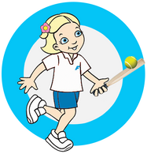
P ROGRESSION OF KEY SKILLS
Rounders
Early Years (progressions through first PE unit/Enjoy-a-ball)
EY

Experiment with different ways of throwing a beanbag,tennis ball over a short distance
Experiment with throwing underarm at targets
Hand eye co-ordination developed through hitting a tennis ball, using throw down strips, hitting a balloon in the air
Rolling the ball to a partner and stopping the ball

1
Year 1 (progressions through kwik cricket and tennis
Throw underarm and introduce overarm. Throw and catch various size balls Bowling at various sized targets
Hand eye co-ordination - hitting a ball with a tennis racket along the floor and in the air
Rolling the ball to a partner, stopping it with hands, bending knees and moving to the ball Begin to develop tactics for adapted striking and fielding games

2
Year 2 (progressions through kwik cricket and tennis
Throw underarm and begin to improve distance thrown with overarm, and catch a ball with control
Underarm bowl at a various sized targets with control
Hitting the ball with a feed and self feed - to develop hand eye co-ordination
Stopping the ball using one or two hands
Develop tactics for adapted striking and fielding gamesi

3
Year 3
Throw under/over arm and catch a ball with control and some accuracy Bowling a ball (between the batters knee and head) from a short distance
Using various equipment to strike the ball with adapted bats e.g tennis racket, rounders bat
Stop the ball using two hands and attempt a long barrier
Adapted games, with variations of rules, begin to apply some basic principles, through striking and fielding
Year 4
Throw under/over arm over varying distances and catch a ball with control and accuracy
Beginning to bowl from the correct bowling distance 7.5 metres Stepping into the hit when striking the ball with a rounders bat Long barrier moving into position to scoop up the ball
Play adapted games, Children encouraged to think of tactics when striking and fielding
4

5
Year 5
Throw and catch the ball sometimes making the correct decisions in a game situation
Introduce a donkey drop bowl
Begin to hit the ball in different directions
Field the ball using long barrier and attempting the run and scoop
In a team, discuss tactics of striking and fielding

Year 6  Throw and catch, making correct tactical decisions having an impact in a game situation | 6
Use a variety of bowling techniques, beginning to add speed to the underarm bowl | 6
Hit it in a variety of directions and look for space in a game situation
Use the run and scoop and throw to another player on my team
Use techniques learned and apply in a game situation. Apply basic principles for striking and fielding

