

Academic years 2025-2027

- We are using the Sport Premium to improve the quality of PE and Sport provision in the following ways:
- We use the funding to support regular sport tournaments, festivals and competitions for pupils of all ages. We continue to be a part of our Local Sports Partnership which has given our pupils the opportunity to participate in a range of sporting activities and competitions.
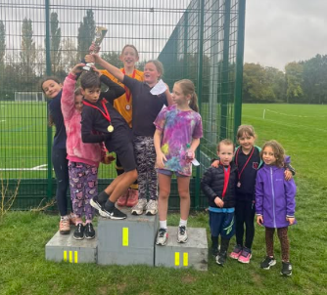
- 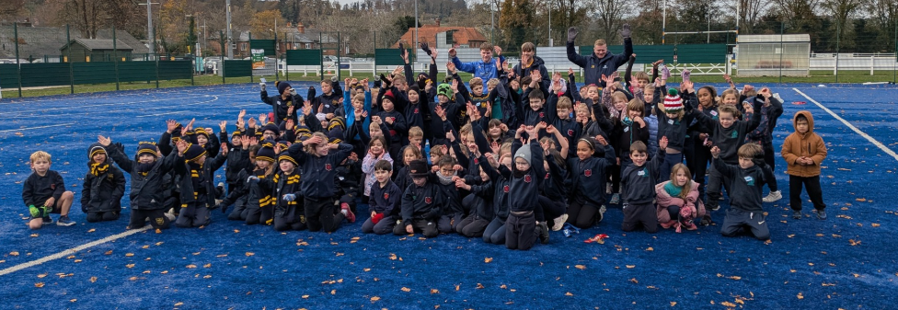
- We invest in high quality CPD for staff to ensure children receive a high level of teaching throughout their time here
- We invest in high-quality visiting sports coaches to run clubs, competitions, and to increase pupils’ participation in in-school and inter-school games competitions. We provide after-school sport clubs as well as a dedicated sports coach at lunch times.

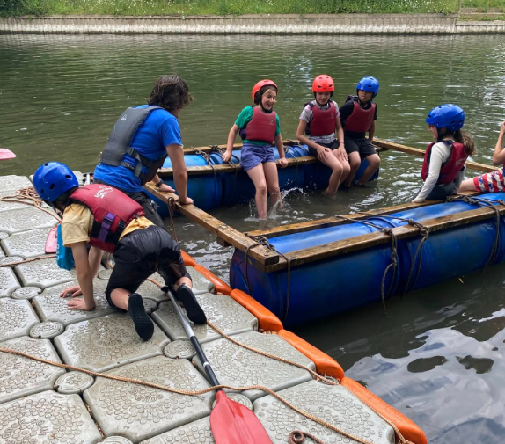
- Our different sports clubs are lots of fun and we try to provide signposting to clubs outside of school to develop these skills further.
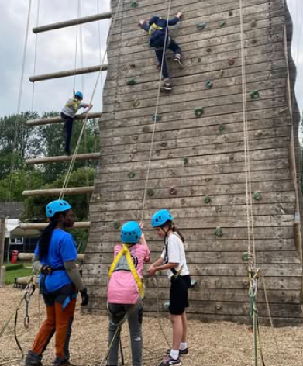
- Upper Key Stage 2 children swim at The Henley Leisure Centre. We greatly value this, because not only does it provide us with access to high-quality swimming facilities but teaches children a vital life skill.
- Year 6 children take part in an outward bounds residential at Longridge Not only does this improve their fitness it also gives them opportunities to try more adventurous sports.

by:
Key priorities and Planning

Total Amount of PPSG expected 2025-2026: £16,970
Action – what are you planning to do | Who does this action impact? | Key indicator to meet | Impacts and how sustainability will be achieved? | Cost linked to the action
Continue with sport specific primary PE planning to ensure our curriculum is progressive, inclusive and engaging and that teachers feel confident in their teaching | Teaching staff/coaches and children | Key indicator 1- increased confidence, knowledge and skills of all staff in teaching PE | Outcomes in PE continue to be at least good.  Pupils are exposed to a range of sports and a life long love of physical activity is promoted | £395
Sports coaching  Sports coaches to work alongside teachers to improve subject knowledge | Teaching staff/coaches and children | Key indicator 1- increased confidence, knowledge and skills of all staff in teaching PE | Staff to work alongside coaches. Improve the provision of PE at Sacred Heart. Staff to be confident and knowledgeable in all areas of PE. | £8350
Lunchtime sport  activities for pupils | Lunchtime supervisors,  teaching staff and coaches | Key indicator 2 -The engagement  of all pupils in regular physical  activity – the Chief Medical  Officer guidelines recommend  that all children and young  people aged 5 to 18 engage in at  least 60 minutes of physical  activity per day, of which 30  minutes should be in school.  Key indicator 4: Broader  experience of a range of sports  and activities offered to all pupils | More pupils meeting  their daily physical  activity goal, more  pupils encouraged to  take part in PE and  Sport Activities | £5,200
Attend a wide range  of sporting activities  both intra and inter to  give pupils the  opportunity to  participate in  competitive sport | Children | Key indicator 4: Broader  experience of a range of sports  and activities offered to all pupils | Participate in planned  events  Staff/coaches to organize  intra events in school  Hold a competitive  school sports day for all  year groups | £650
Purchasing quality  assured material for  P.E/Sport | Teaching Staff, coaches, P.E  coordinator and after school  club leader.  P.E co-ordinator and after  school club leader audits and  replaces equipment to ensure  quality of provision. A variety of  keeping fit, healthy, active  projects are undertaken | Key Indicator 3: Engagement of  all pupils in regular physical  activity | Increase quality  provision and expand  ideas methods and ways  of keeping fit.  Children use specialized  equipment to gain new  skills. | £1000
Purchasing  playground equipment  to improve physical  activity in KS1 and 2 | Teaching Staff, coaches, P.E  coordinator and after school  club leader. | Key Indicator 3: Engagement of  all pupils in regular physical  activity | Improve quality and  amount of equipment.  Improve opportunities  for physical activities.  Pupils will be more  active during playtimes  and lunchtimes  contributing to 30  minutes every day. | £500
Sport Safe equipment  check to ensure safe  equipment  Repairs and maintenance to outdoor equipment | Sports coaches, staff and children | Key Indicator 3: Engagement of  all pupils in regular physical  activity | Pupils are using safe  equipment. | £1050
Children in upper ks2 have access to swimming lessons | pupils | Key Indicator 3: Engagement of  all pupils in regular physical  activity | increased number of  pupils able to swim 25m  by the end of Year 6. | Sports grant funds not used for this.

