
SACRED HEART CATHOLIC PRIMARY SCHOOL - CATHOLIC SOCIAL TEACHING PLAN
2025-2026

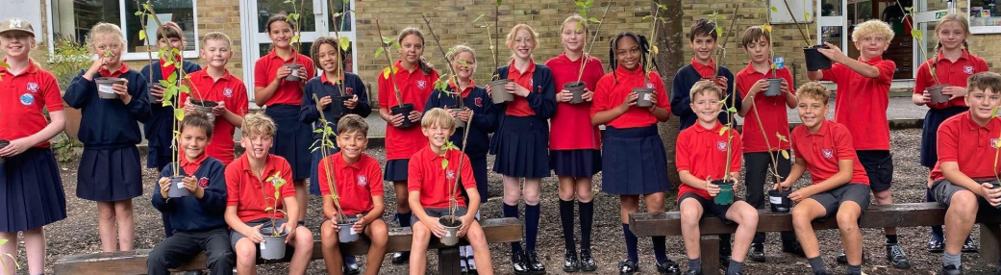
TERM | CATHOLIC PUPIL PROFILE | CATHOLIC SOCIAL TEACHING | FUNDAMENTAL BRITISH VALUES/ | WHOLE SCHOOL  EVENTS (including charitable outreach) | PUPIL LEADERSHIP
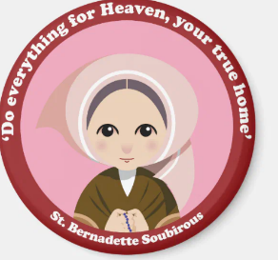  AUTUMN 1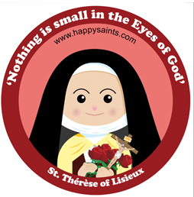 | ELOQUENT AND TRUTHFUL | 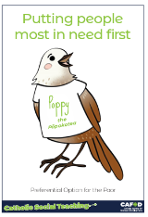  OPTION FOR THE POOR  We believe that all resources on earth should be shared with all. We find ways to work together to support the poor and vulnerable.  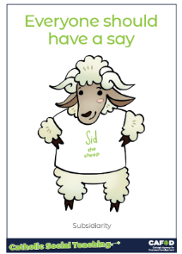  Subsidiarity  making sure decisions are made at the most appropriate level, so all those affected can contribute and have a voice.  Elect the new school council Head boy/Girl/House Captains | Rule of Law Understanding rules and why they are important  Following rules | Harvest – collection for local/parish food bank  Choir singing to Chiltern Court Care Home  Elliot’s Arc  Little Way Week  (29/9- 3/10) led by Year 4/5  Whole School Litter Pick | New school council elected  New positions of responsibility applied for and awarded  Little Way Week (29.9.25)  Completing small, planned acts of kindness to bring positive change to our neighbours in both the local community. As well as around the world.
AUTUMN 2  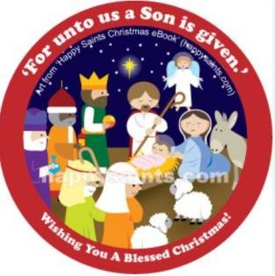 | 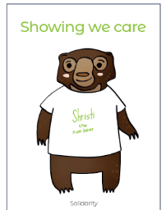  LEARNED AND WISE | 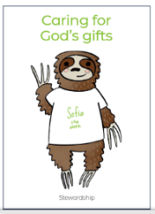  Stewardship – Caring for God’s Creation and Gifts.  Taking responsibility for our environment, making environmentally responsible choices.  - (House Battery recycling Competition)  - School council to Greener Henley Science Fair & Apply for Green Futures Award  Solidarity  Recognising others as our brothers and sisters and actively working for their good (Year 6 to lead Cafod’s Cancel the Debt Campaign) | 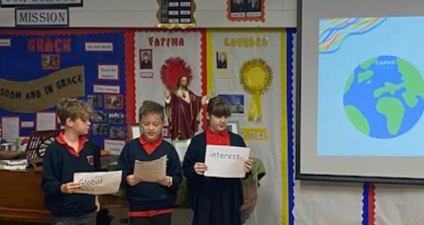  Democracy: Encouraging our community to understand their role and responsibilities so that no one is deprived of their resources | Remembrance Day    End of term Awards  – Virtues and Values  STC award for Catholic Life  Diocesan Year of Jubilee celebration event 21.11.25 | Pupils to lead fundraising for the Royal British Legion and Remembrance Day Service (assembly). Head girl and boy laying wreath in town square  Choir singing at Kenton Carol Evening  Anti-bullying week & friendship Friday 10-14.11.25

TERM | CATHOLIC PUPIL PROFILE | CATHOLIC SOCIAL TEACHING | FUNDAMENTAL BRITISH VALUES/ | WHOLE SCHOOL  EVENTS (including charitable outreach) | PUPIL LEADERSHIP
SPRING 1    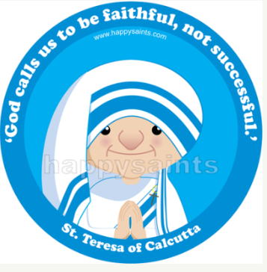 | CURIOUS AND ACTIVE  Saint Teresa of Calcutta (link with curious and active as well as our end of term award) | 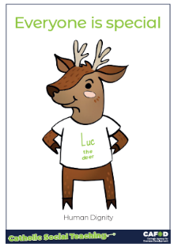  Human Dignity  We respect and uphold the dignity of each and every individual.  PARTICIPATION    We all have a right and duty to participate fully in society  (Link to faith Week)  St Valentine (Feast Day Feb 14th) | Tolerance  Faith week provides opportunities to learn about different cultures and beliefs to reinforce messages of tolerance and respect allowing all to understand and respect differences.  This term: Islam | Jubilee Year ends with the Feast of the Epiphany    Safer Internet Day  (10.2.26)  Faith Week  (w/b 9.2.26)  Henley Youth Festival  – using our skills and talents | Live Simply assessment (13.2.26)  Class Assembly for Faith Week
SPRING 2  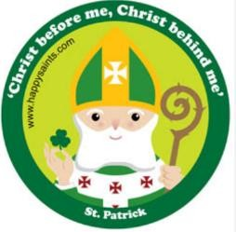 | INTENTIONAL AND PROPHETIC | DISTRIBUTIVE JUSTICE  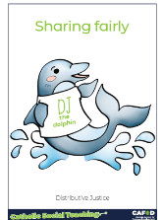  Recognising we need to share the world’s resources fairly  Fundraising Project – Cafod The Big Walk | Individual Liberty Promote the freedom of choice and the right to respectfully express views and beliefs in a safe environment | Lent – CAFOD Science week – ‘curiosity what’s your question?  End of term Awards  – Virtues and Values STC award for Catholic Life  School Council  The Big Walk – CAFOD  STAY AND PRAY SESSION IN CLASSES  STATIONS OF THE CROSS | Liturgy Leaders  Monitor prayer spaces
SUMMER 1  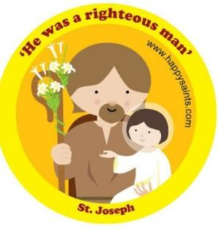  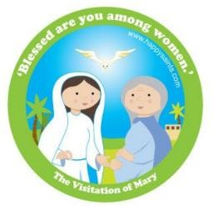 | GRATEFUL AND  GENEROUS |   PEACE  Peace is part of God’s nature, and a value we should all seek to live out in our daily lives.  Interfaith prayers for peace. (linked with faith week) | Mutual Respect Equality and promotion of our rights  Working together to create friendships  Recognising differences and valuing them. Respecting ourselves, the environment and those needing help | Transition Events – welcome gifts, buddy letters and activities for the new intake  May is the month of Mary – prayer spaces to offer praying the rosary  May Procession  Faith Week: Judaism  Vocation Saints Museum – Year 6  Current buddies train new buddies (extended to Year 5) | Year 1 leading May procession

SUMMER 2   | ATTENTIVE  AND  DISCERNING | 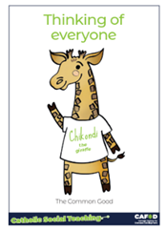  THE COMMON GOOD  Our actions have an impact on everyone. When we make decisions, we should consider the good of all.  Local Fundraising/Charitable Projects |  | Pentecost  FEAST DAY  First Holy Communion Confirmation  End of term Awards  – Virtues and Values STC award for Catholic Life | School council  Review of climate action Plan  Review CST plan

