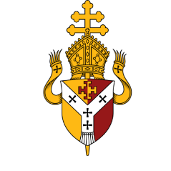

THE ARCHDIOCESE OF BIRMINGHAM

Sacred Heart Catholic Primary School


‘To Grow in Wisdom and in Grace’

Prayer and Liturgy Policy

Table of contents

Rationale 3
Statement of requirement 3
Responsibility 4
Aims… 5
Mission 5
Opportunities for Acts of Prayer and Liturgy 6
Planning Prayer and Liturgy – The Four Part Model 8
Planning a Mass 8
Prayer Areas 9
Resourcing …………………………………………………………………………………………………………..9
Training & Formation ……………………………………………………………………………………………...9
Monitoring ………………………………………………………………………………………………………….10
Appendices ………………………………………………………………………………………………………….11

We should never underestimate the ability of young people to be open to contemplative prayer. We need only find the right ways and means to help them embark on this precious experience.
-Pope Francis

Rationale
As a Catholic school, our curriculum, worship and ethos is centred around the teachings of Christ. Within our school, prayer and liturgy is far more than a statutory requirement. It is an essential part of our distinctive identity; a way of celebrating our faith and deepening our relationship with God through prayer, reflection, praise and celebration. Our staff ensure that children are provided with opportunities to develop their spirituality and a close relationship with God through acts of worship. In developing a deep sense of spirituality, our children are prepared to live out their lives in accordance with their vocation. We aim to make the liturgical life of the school both creative and diverse to ensure that we stimulate and challenge the children in a spiritual way. This policy has been devised to support the liturgical life of the school by providing guidelines for various acts of prayer. We also recognise the rich diversity in the mutli-cultural society in which we live. We reflect other cultures in our worship and teachings, where appropriate and we compare faiths to enable us to deepen our understanding of our own faith.

Statement of Requirement

The law requires all maintained Catholic schools to provide an act of daily collective worship (prayer and liturgy) for all pupils, including those in the sixth form (Section 70, 1988 Education Act) that is in accordance with the rites, practices, disciplines, and liturgical norms of the Catholic Church (School Standards and Framework Act 1998, schedule 20;

Instrument of Government, clause 2). Academies in England are required by their funding agreement and Articles of Association to comply with similar requirements (The Mainstream Academy and Free School: Supplemental Funding Agreement, December 2020; Model Articles for Catholic Academies, February 2019).

The law requires all maintained schools to recognise and respect that parents have the legal right to withdraw their children up to the age of 16 from prayer and liturgy (School Standards and Framework Act 1998, s.71(1A)). Sixth-form pupils can choose to withdraw themselves from prayer and liturgy (School Standards and Framework Act 1998, s.71(1B)).

The school’s provision for prayer and liturgy will fulfil pupils’ entitlement to experience the range of liturgical treasures of the Church, including a shared repertoire of prayers and liturgical music with which pupils in the school will be familiar.

Prayer and liturgy are not designated curriculum time. In the context of the Catholic school, this means that times of prayer and liturgy are not considered to be part of the allocation of curriculum time for Religious Education.

Responsibility

(a) Governance
The governors, as guardians of the Catholic school’s life and mission, have a responsibility
to ensure that:
• prayer and liturgy are central to the Catholic life of the school and therefore are in line
with the guidance set out by the Prayer and Liturgy Directory
• there is a named person(s) who is responsible for prayer and liturgy in the school (the
Prayer and Liturgy Coordinator)
• the prayer and liturgy policy is updated regularly and shared with all stakeholders
• there is a budget for prayer and liturgy that reflects its centrality to the life of a
Catholic school.

(b) Headteacher

The headteacher, as the spiritual leader of the school as a Catholic community,
ensures that:
• prayer and liturgy are central to the Catholic life of the school and therefore are in line
with the guidance set out by the Prayer and Liturgy Directory
• they work in partnership with the leader(s) for prayer and liturgy
• those responsible for prayer and liturgy in the school have been given appropriate
training and formation to ensure that all guidance is followed and adhered to
• there are suitable resources for prayer and liturgy in the school.

(c) Prayer and Liturgy Coordinator

Those responsible for prayer and liturgy ensure that:
• prayer and liturgy are central to the Catholic life of the school and therefore are in line
with the guidance set out by the Prayer and Liturgy Directory
• there is an Annual Plan of Provision for prayer and liturgy across the school year which
identifies liturgical seasons and key celebrations, as well as opportunities for the
celebration of the Sacraments
there is daily planned prayer for all pupils, appropriate to age and ability, as outlined in
the Prayer and Liturgy Directory
• pupils are supported in their liturgical formation to take an active role in the planning,
preparation, and delivery of prayer and liturgy according to their age and capacity,
and in a manner which facilitates their progressive participation
• resources to support the planning of prayer and liturgy are appropriate and readily
available to staff and pupils
• induction on prayer and liturgy takes place for new members of staff as required
• staff have access to effective training and formation opportunities
• monitoring and evaluation of prayer and liturgy take place regularly and feed back into
planning for future liturgies
• monitoring of prayer and liturgy is reported to the headteacher and governing body to
support whole-school development and the Catholic life of the school
• there is collaboration with local clergy and parishes
• liaison with the Diocesan Advisory Service and others is maintained to ensure they keep
updated with best practice.

Aims

Prayer and liturgy provides an opportunity for every member of the school community to:
- Pray by giving praise, thanks and intercession to God using traditional prayers of the Catholic Church and many other sources of prayer.
- Come to know and acknowledge the presence of God who is revealed to us as Father, Son and Holy Spirit.
- Nurture a relationship with God through words, symbols, song, gestures and silence.
- Experience a sense of belonging.
- Learn how the liturgy of the church is structured and the meaning of the different parts of the liturgical rites.
- Develop the school community of faith.
- Bear witness to the community and wider world.
- Reflect on spiritual and moral issues.
- Develop shared values and a common ethos.
- Understand the four part structure of a liturgy so that children can plan and deliver their own.
- Engage in spontaneous prayer.

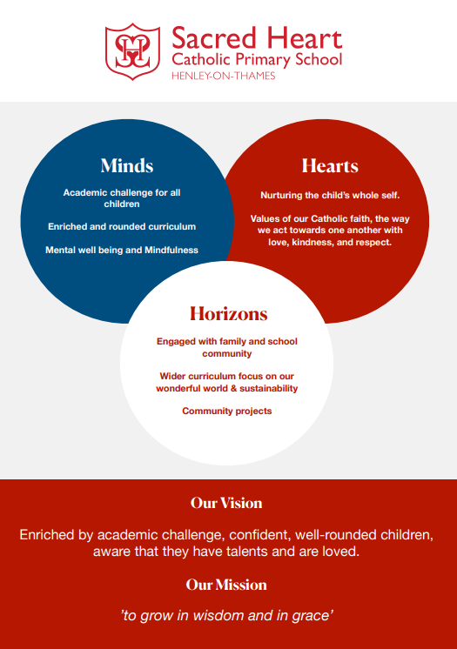
Mission
The Catholic Life of the school is given the highest priority where the development of an authentic Catholic ethos is actively sought by all. Children are empowered to have a thorough understanding of the Church’s liturgical year, its seasons, rites and symbols. Within the school community, prayer has a profound and visible effect on the development of all pupils and staff irrespective of ability or faith background. As a school, we promote a love of faith; engaging and inspiring our children to take responsibility for promoting the Catholic ethos of our community whilst seeking to lead and develop this further. Developing a greater understanding of vocation is fundamental in giving our children a meaningful reason to live out their faith. Teachers ensure that children are provided with opportunities to develop their spirituality and respond to questions of faith. Our school celebrates, develops and enhances the Catholic Life of our children and ensures our Catholic ethos underpins all that we do and strive to achieve.

Opportunities for Acts of Prayer and Liturgy

Class time
- Prayers will be said in class at least four times a day (morning, before lunch, after lunch and at the end of the day). This follows the pattern of prayer within the church. Children may be selected to lead prayers during this time.
- Special intention prayer times will be delivered by class teachers, when appropriate, in response to the needs of the community or to a key event.
- Sessions take place throughout the year in order for children to learn the traditional prayers allocated to their year group (see appendix 12 for progression overview).
- Child led (and teacher led) prayer takes place weekly. These liturgies have specific themes, which align with the liturgical year e.g. reconciliation and forgiveness during Lent. Expectations for participation in the planning and delivery of prayer can be found in appendix 5, in line with children’s growth in age and confidence.
- Children have the opportunity to set up prayer spaces in their classrooms in line with the Liturgical calendar.

Assemblies
- Each Monday, the Head teacher will lead a whole school Gospel (mission) assembly. These assemblies provide the children with an opportunity to reflect on the meaning of the Gospel from the previous Sunday and is also used to introduce pairs of virtues at the start of a half term. At the end of each gospel assembly, the children are given a mission task to complete over the course of the week. Assemblies are evaluated by the children, whose feedback is considered for future assemblies (see appendix 9).
- Occasionally, guest speakers will be invited to lead assemblies e.g. representatives from CAFOD/ Father Hudson.
- Each week, a celebration assembly takes place on Friday morning for the whole school. This assembly focuses on celebrating the God-given gifts and talents of children and how we can use these for the good of others.
- Hymn practice takes place once a week to enrich prayer and liturgy.
- Over the course of an academic year, each class will lead at least one class assembly to deliver to the school community. The assembly may be based on sharing their chosen Catholic Life Pledges, or specific themes, such as those relating to Holy Week, Anti- bullying week, Black History Month, etc.
School Liturgy and Mass
- Throughout the year, there will be opportunities for the School and Parish community to come together in worship and participate in the Mass. Each mass focuses on a particular theme/celebration in the Church’s calendar/Saint’s Feast Day.
- Every class prepares and leads a Mass throughout the year, with parents, families and parishioners warmly welcomed (see appendix 3 for mass planner).
- Penitential services are carried out during Lent for whole school. Children receive ashes on Ash Wednesday as a Mass/Service.

Other Experiences
- During the months of May and October, the school holds a lunchtime Rosary Club for pupils and staff.
- Retreats such as the Year 6 Visit to Stonor in the summer term take place within school.
- Liturgical experiences such as the May Crowning and Stations of the Cross take place within school to which families and parishioners are invited.
Links with the Parish, Community and Families
- Every child has the opportunity throughout the year to take a prayer bag home. This bag contains a prayer journal and items to support the planning and delivery of a four-part liturgy.
- Families and Parishioners are invited to attend Masses and assemblies throughout the school year.
- Families are invited into school to participate in Sacramental retreats in Years 3 (Reconciliation and First Holy Communion) and Year 6 (Confirmation).
- The children in Year 3 receive Sacramental support from the Parish Catechist in preparation for receiving the Sacrament of Reconciliation and First Holy Communion.
- Families are invited to participate in classroom liturgies at least once a year.

Raising Awareness of Prayer and Liturgy
- The newsletters regularly highlight the importance of Prayer and Liturgy in our school and examples are celebrated.
- The Headteacher report to Governors includes an overview of Prayer and Liturgy. This is reported termly.

Planning Prayer and Liturgy – The Four Part Model

In every act of communal Prayer and Liturgy, a four-fold model is to be observed. The model is based upon the principles of: Gather, Listen, Respond and Go Forth. This structure reflects the four parts of the Mass.
Gather – In our coming together for Prayer and Liturgy, we acknowledge the presence of Christ with us. Reflective music, lighting of candles and/or a procession can all contribute towards helping the community to enter into a time of prayer together. Making the sign of the cross will also signify entrance into a time of prayer. Consideration will be given to seating and posture for Prayer and Liturgy so that the community has an awareness that it has gathered together to pray. The use of a focal point connected to the Liturgical season/appropriate feast day will support the gathering to pray.
Listen – God’s word is proclaimed from the Scriptures. The chosen readings are closely associated with the current liturgical season, feast day or memorial. The Word of God is proclaimed from the Bible or the Lectionary, highlighting the reverence we give to the Word of God. The reader will always clearly announce where the reading comes from and will use the appropriate reading conclusion to which the community members makes the appropriate response. If the Gospel is proclaimed, it is accompanied by the action of making the sign of the cross on the forehead, lips and heart. A few moments of silence will be given following the reading to allow everybody to reflect on what they have heard.
Respond – This is a ritual movement that everyone can join in with, which fits in with the theme. This may include, but is not limited to, singing a hymn, silent personal reflection, prayers of intercession, guided meditation or a written response.
Go Forth (mission) – In concluding a Prayer and Liturgy session, children are given something to hold onto from their prayerful experience so that they can take the message and apply it in their lives. Examples may include a final prayer, a physical prompt to share at home with families or a mission task to complete.
In appendices 6, 7 and 8 within this document, there is a guide and planning templates to assist teachers and pupils in the planning of their liturgies.

Planning a Mass

The celebration of the Eucharist is given a place of great importance in the life of Sacred Heart Catholic Primary School. It is an essential ingredient to the life of our Catholic community. The Religious Education/Prayer and Liturgy leader, alongside the Parish Priest, decide when the celebration of the Eucharist will take place throughout the school year. The following will be considered: the beginning and end of terms/school year as moments of dedication and thanksgiving to God; the major liturgical seasons of the Church year, especially Advent, Lent, Eastertide and Pentecost; and Holy days of obligation and other Feasts.
Whole school masses will take place in the school hall or church and are planned routinely throughout the year. It is the responsibility of the RE/Prayer and Liturgy leader, with support from the Catholic Life Leaders, to set up for Mass. Families are routinely invited to share in this celebration of the Eucharist.

Class Masses will take place in the classrooms These masses are planned on a rota basis throughout the school year by the RE/Prayer and Liturgy leader and Parish Priest. It is the responsibility of the class teacher, with support from pupils, to plan and set up for the mass. In appendix 3 in this document, there is a guide and planning templates to assist teachers and pupils in the planning of the Mass.

Prayer Areas

Each classroom has a prominent prayer area which is in keeping with the liturgical colours of the Church (see appendix 1 for guidance on Liturgical colours). The Liturgical year cycle is displayed at all times along with the relevant poster highlighting the key dates and themes for the specific part in the Church’s year, along with appropriate prayer and hymn ideas. Each prayer area will contain a range of relevant religious artefacts and reflect the Catholic Schools Pupil Profile virtues of the half term. The Holy Bible is displayed in each prayer area and is opened at a relevant page, namely the Sunday Gospel reading. Prayer areas are regularly monitored by the RE/Prayer and Liturgy lead and pupil Catholic Life Leaders and feedback is routinely given to staff.

Resourcing

Prayer and liturgy are central to the school’s understanding of itself as a Catholic school, and this is reflected in the annual budget allocation and available resources, including staff time, chaplaincy provision, and dedicated spaces for prayer and liturgy. The Catholic character of the school is reflected in religious artefacts and images on display throughout the building. Dedicated spaces for prayer and liturgy will be furnished and maintained as such, and updated to reflect the Church’s liturgical season. Staff training and formation costs will be funded separately to ensure that all staff are able to fulfil their responsibility to contribute to the prayer and liturgical life of the school.

Training and Formation

All new staff will be supported during induction and beyond, so that they fully understand the responsibility they carry within their individual role for leading prayer and liturgy in the school. Any individual training needs will be identified and addressed through training and formation. There will also be the opportunity for whole-staff professional development at least once a year, so that all staff understand the importance of prayer and liturgy and relevant staff are well supported to lead as required.

Monitoring

The school’s provision of Prayer and Liturgy is evaluated termly, in accordance with the school’s monitoring timetable. Monitoring considers how our provision meets the needs of pupils and whether it truly reflects the aims and mission of the school. This may be in the form of observations of child/teacher led liturgy, prayer bag monitoring, liturgy folder monitoring or pupil voice.
Monitoring of prayer areas and the school environment are also carried out by the School Council. Outcomes of all monitoring are shared with the School Leadership Team, school teaching staff and Governors.

Appendix 1 – Liturgical Colours
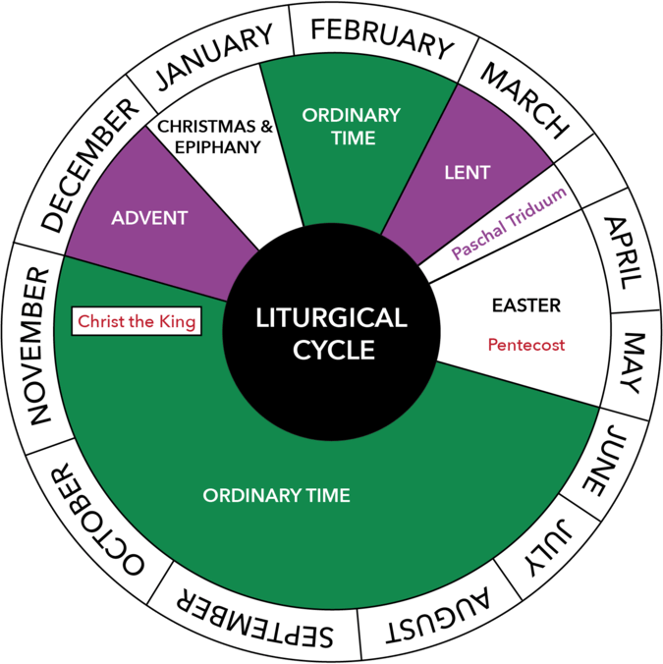
What is a Liturgical Calendar?

The Liturgical Calendar begins every year during the month of November on the First Sunday of Advent and runs through to the Solemnity of Christ the King.

The "Lectionary," the Mass readings from the Holy Bible, follows a Sunday cycle and a weekday cycle. The Liturgical Calendar follows a three-year cycle, each year being represented by the letters, A, B, and C. During the year A cycle, the Gospel of Matthew is the primary Gospel that is used for the readings. In year B, Mark is the primary Gospel. In year C, Luke is the primary Gospel. The Gospel of John is proclaimed on particular Sundays in each of the years.

Seasons of the Liturgical Calendar
In each cycle of the Liturgical Calendar, there are six Seasons:

  - Advent
  - Christmas
  - Lent
  - Triduum
  - Easter
  - Ordinary Time

During the year, in addition to the Sunday worship, the Church also celebrates Solemnities, Feasts, and Memorials, which may be on any day of the week. These occur during the year to commemorate special events or persons that are highly revered by the Catholic Church.
The colour of the priest’s vestments and other garments around the Church change at different times in the Church’s liturgical calendar. The prayer areas and religious displays around the school should also change, in line with the liturgical colours of the Church. The liturgical year cycle is displayed at all times, in every classroom, along with a relevant poster to highlight key dates and themes within a particular season.
Liturgical Displays/Prayer Areas
Green – symbolising life, hope and growth. This is to be used during Ordinary Time.
Purple – symbolising penance and preparation. This is to be used during Advent and Lent.
White – symbolising purity, holiness, joy, innocence and triumph. This is to be used during Christmas and Easter.
Red – symbolising fire and blood. This is to be used during Pentecost, Palm Sunday and Good Friday (or liturgies relating to these events). Additionally, it is appropriate to use red for liturgies relating to feast days of Saints who are martyrs.
Blue – symbolising Marian Feasts. This is to be used for liturgies relating to Mary and in the months of October and May. Blue will be used to celebrate The Feast of the Annunciation and The Feast of our Lady of Lourdes.

Appendix 2 – Planning a Mass Guide

Which Mass should be celebrated?
In making preparations for the celebration of the Eucharist in school, consideration should always be given to when the celebration is actually taking place within the liturgical year. The choice of readings and the prayers used for the Mass should take into consideration the season of the year, whether the day for the celebration is a solemnity, a feast day, a memorial of a saint or an ordinary weekday.
What readings and prayers should be used?
On a day designated as a solemnity or feast, the readings and prayers should always be for that day. Memorial days provide an opportunity to honour the lives of the saints and seek their intercession. The use of liturgical prayers associated with these saints is encouraged. On ferial days (weekdays), there is an opportunity to consider other prayers and readings.
The intercessions (bidding prayers) that accompany the Liturgy of the Word at Mass should follow the formulae outlined in the General Instruction of the Roman Missal: The Church, the world, local community, any other needs and Mary. The intention to pray should be announced followed by a short period of silence and the response then made.
What music should be used?
Planning music for mass should be given careful consideration. It is not just choosing pupils’ favourite hymns. Hymns should be appropriate to the season and reflect what is being celebrated at mass. The following hymns should be chosen: processional hymn, offertory hymn, communion hymn and recessional hymn.
What Ministries should be used in School Masses?
The Eucharistic liturgy demands the full, conscious and active participation of everybody gathered for the celebration.
Priest – Presides over the celebration of the Eucharist, teaches through the homily, reads the Gospel and distributes Holy Communion.
Ministers of the Word – All readers should be adequately prepared and should understand the Word that is being proclaimed.
Eucharistic Minister – Appropriately trained and commissioned ministers of the Eucharist may assist the priest in distributing Holy Communion.
Altar Servers – Assistants to the priest.
Congregation – Singing hymns and joining in with responses throughout the Mass.

Appendix 3 – Mass Planning Proforma
(available in staff shared drive under Mass folder)

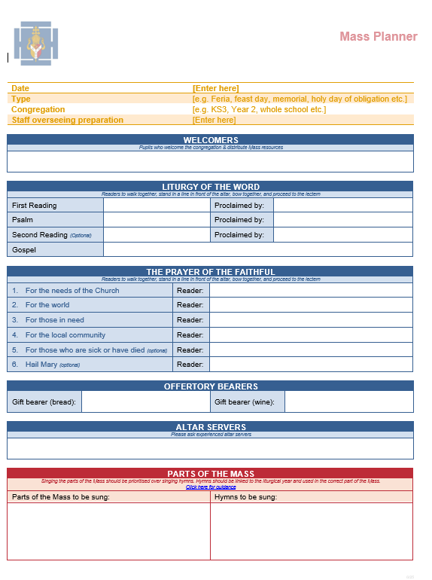
Appendix 4 – Items used at Mass

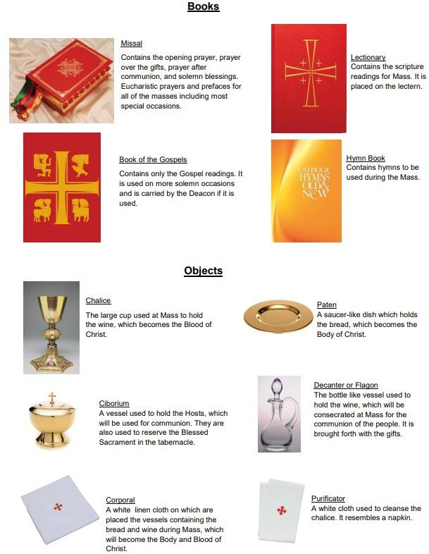

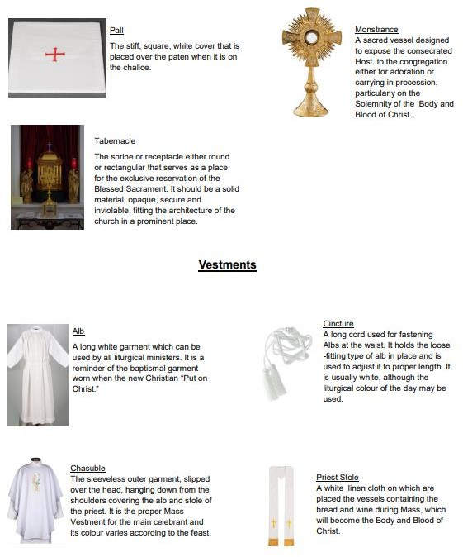

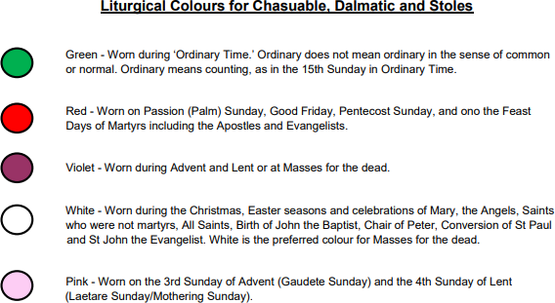
Liturgical Colours for Chasubles and Stoles

Appendix 5 – Prayer and Liturgy Expectations
 | Reception | Class liturgy is timetabled weekly. At the start of Reception, the teacher will use the teacher planning proforma to plan and deliver appropriate liturgies.  Children will begin to take ownership of setting up the prayer area at the beginning of liturgy and packing it away respectfully at the end. Children will begin to take ownership over what is placed on the prayer area and begin to explain why they have chosen certain items/religious symbols.  Children will take it in turns to take their prayer bag home weekly and conduct a liturgy at home with their families, providing evidence in their prayer bag journal.
 | Year 1 | Class liturgy is timetabled weekly.  From the beginning of year 1, children will work in small groups using the diocesan A3 liturgy planner, facilitated by an adult. An adult will scribe the plan for them on the A3 planner. Children will lead different parts of the liturgy with help from their teacher. The teacher will model a liturgy at least once per half term, including whole school liturgies sent by the Prayer and Liturgy lead.  The children will set up the prayer space, choosing different religious symbols to signify the theme of their liturgy and will begin to explain the significance of what they have chosen.  The children will have a good understanding of the liturgical year and the colours used in each season. With assistance from an adult, each half term at least one peer, self and teacher evaluation will be completed.  Children will take it in turns to take their prayer bag home weekly and conduct a liturgy at home with their families, providing evidence in their prayer bag journal.
 | Year 2 | Class liturgy is timetabled weekly.  Children will work in small groups using the diocesan A3 liturgy planner, facilitated by an adult, to plan and deliver weekly liturgies. An adult will scribe the plan for them on the A3 planner.  Children will begin to independently choose the theme for their liturgy and think about appropriate scripture to link with their theme.  The children’s knowledge of the liturgical year will be secure by the end of year 2. They will be able to explain the significance of each season and explain the colours that correspond to this.  The teacher will model a liturgy at least once per half term, including whole school liturgies sent by the Prayer and Liturgy lead.  With assistance from an adult, each half term at least one peer, self and teacher evaluation will be completed.  Children will take it in turns to take their prayer bag home weekly and conduct a liturgy at home with their families, providing evidence in their prayer bag journal.
 | Year 3/4 | Class liturgy is timetabled weekly.  Children will plan liturgies using the diocesan A3 liturgy planner, facilitated by an adult, to plan and deliver weekly liturgies. They will record their ideas on the children’s planning proforma.  Children will independently choose their theme and think about appropriate scripture that links to the theme.  Children will begin to think of differing ways that they can respond appropriately to prayer.

Children will be able to plan an appropriate Go Forth mission task linking to their theme.
The teacher will model a liturgy at least once per half term, including whole school liturgies sent by the Prayer and Liturgy lead.
Children will have a secure knowledge of the liturgical year and will be able to begin to plan liturgies around the liturgical year.
Each half term, at least one of each evaluation will be completed independently by the children (self, peer and teacher).
Children should be given the opportunity to plan and deliver liturgies based around their sacramental preparation of the Eucharist.
Children will take it in turns to take their prayer bag home weekly and conduct a liturgy at home with their families, providing evidence in their prayer bag journal.
Year 5/6 | Class liturgy is timetabled weekly.  Children will independently plan and deliver liturgies using the A3 diocesan proforma and record their ideas coherently on the children’s planning proforma.  Children will independently choose a theme and appropriate scripture to correspond to and link with their theme.  Children will be able to think of appropriate and prayerful ways of responding to the Word of God, including opportunities for spontaneous prayer.  Children will be able to independently choose appropriate music and hymns to link in with their liturgy theme.  Children will be able to plan an appropriate Go Forth mission task linking to their theme.  The teacher will model a liturgy at least once per half term, including whole school liturgies sent by the Prayer and Liturgy lead.  Each half term, at least one of each evaluation will be completed independently by the children (self, peer and teacher). The children will use these evaluations to plan subsequent liturgies.  Children will take it in turns to take their prayer bag home weekly and conduct a liturgy at home with  their families, providing evidence in their prayer bag journal.

Appendix 6 – Celebration of the Word planner Pupil

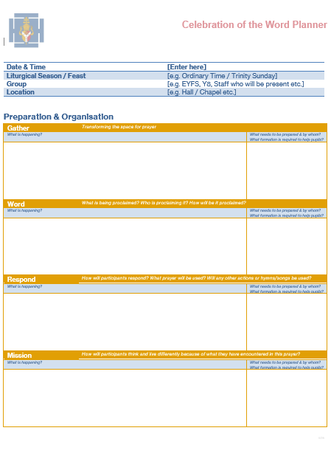
Appendix 7 – Pupil Prayer Planner

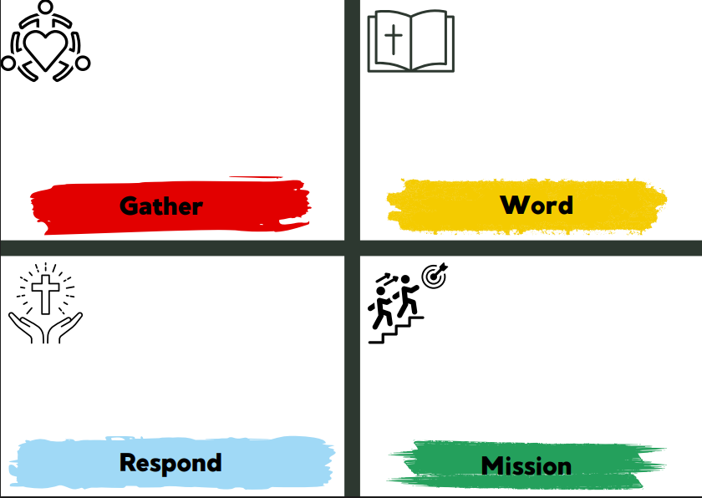

Appendix 8 – Mass Planner

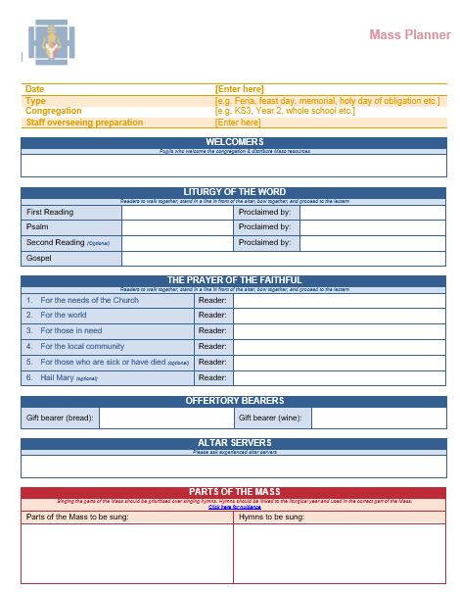
Appendix 9 – Evaluation Proformas (Assembly, Peer, Teacher, Self)

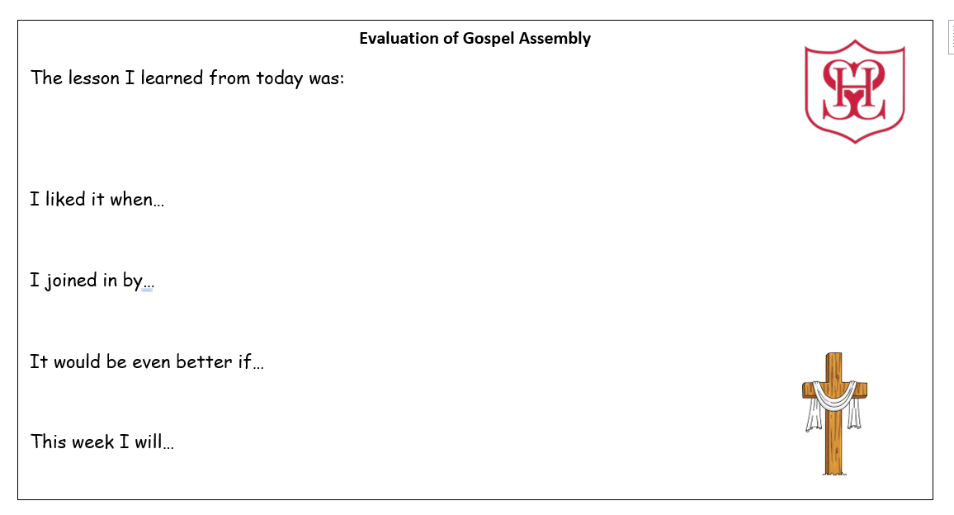

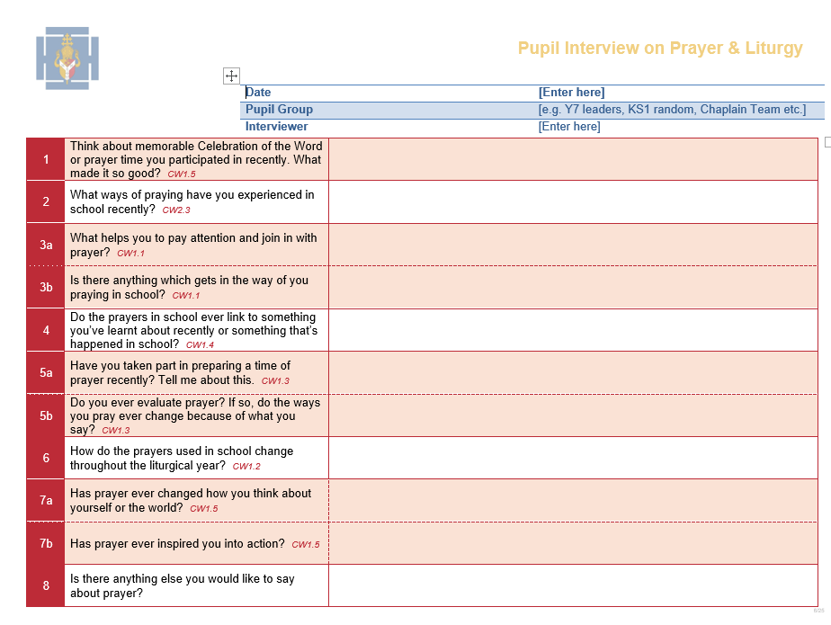

Appendix 10 – Creating a Prayerful Atmosphere

It is important that a prayerful atmosphere is created and maintained throughout the liturgy. It is important to consider that this is special time set aside for time with God and our own personal reflection.
Seating
It is important, mainly based on what you are doing in your liturgy/respond task, to consider how the children are sat. If possible, the classroom should be set up differently than it would in lessons. One way of achieving this is by sitting in a circle. If this is not possible, then it may be that if the children need to move for the respond task, that a level of reverence and spirituality is maintained. It may be that the children make their offering a row at a time rather than all together at once.

Lighting
The lighting of a room is a perfect way to create a spiritual and prayerful atmosphere. By turning off the lights and lighting candles, the atmosphere immediately becomes more peaceful. Wherever possible, it has more impact if the children enter the room once it has been prepared with the low level lighting, candles, music, etc.

Music
In Pope Francis’s exhortation to young people, he states: ‘Music is particularly important, representing as it does a real environment in which the young are constantly immersed, as well as a culture and a language capable of arousing emotion and shaping identity. The language of music also represents a pastoral resource with a particular bearing on the liturgy and its renewal.’
Soft, instrumental music playing in the background can have a calming influence on young people and can set a prayerful tone and atmosphere. Having this music playing as the children process in signals – without words – that it is time for us to welcome the presence of God into our hearts, silently, respectfully and reverently.
There might also be singing as part of the liturgy and this, in itself, can be a vital part of creating a prayerful experience. As St. Augustine says, ‘To sing is to pray twice.’ Any hymns/songs selected should be along the same theme that has been chosen for the liturgy so that the meaning and purpose of the liturgy is reinforced.

Tone of voice
The tone, pitch and volume of your voice when introducing parts of the liturgy are very important. It is still important to speak clearly but slowing down your speech and lowering the volume of your voice signals to the children that this is different to a lesson or assembly and help to create and maintain a spiritual atmosphere.

Appendix 11 – Practical Ideas for Prayer

Click here for :Practical Prayer Guide:

Prayer Stations
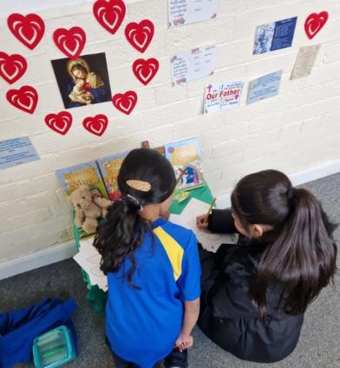

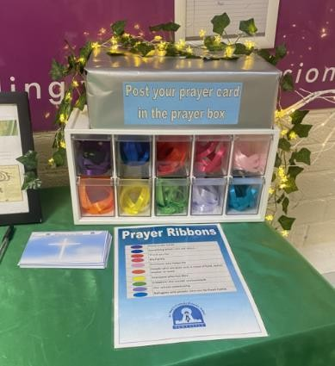
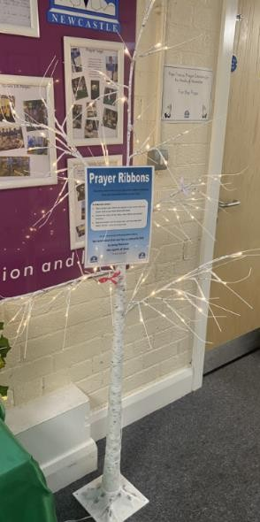
Rainbow Prayers

Prayer Stones
Liturgical Practical Prayer Examples:

May Crowning
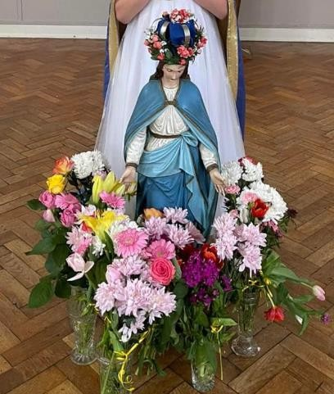
Nativity (The Crib)
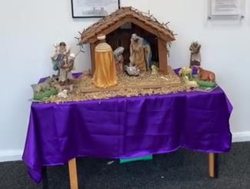

Lenten Prayer Chain

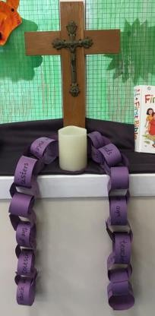

Appendix 12 – Whole School Prayer Overview including Known Prayers



